 | 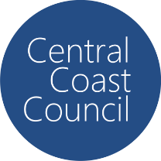
COUNCIL ASSESSMENT REPORT
HUNTER AND CENTRAL COAST REGIONAL PLANNING PANEL

PANEL REFERENCE & DA NUMBER | PPSHCC-329 – DA/1424/2024
PROPOSAL | Construction and Operation of Greenhouse
ADDRESS | Lot 141 DP 755246 (1419 Peats Ridge Road, PEATS RIDGE)
APPLICANT | PMANDO Holdings Pty Ltd
OWNER | Diverse Agri Investments Pty Ltd
DA LODGEMENT DATE | 2 October 2024
APPLICATION TYPE | DA (Nominated Integrated)
REGIONALLY SIGNIFICANT CRITERIA | Clause 2, Schedule 6 of State Environmental Planning Policy (Planning Systems) 2021 : General development over $30 million
CIV | $51,895,380
CLAUSE 4.6 REQUESTS | N/A
KEY SEPP/LEP | State Environmental Planning Policy (Planning Systems) 2021  State Environmental Planning Policy (Primary Production) 2021  State Environmental Planning Policy (Resilience and Hazards) 2021  Central Coast Local Environmental Plan 2022
TOTAL & UNIQUE SUBMISSIONS KEY ISSUES IN SUBMISSIONS | Two
DOCUMENTS SUBMITTED FOR CONSIDERATION | Architectural Plans (Issue C)  Noise Impact Assessment (Revision 3)  Air Quality Impact Assessment (Revision 3)  Bushfire Access Design Compliance Statement (August 2025)  Civil Engineering Plans (Revision 5)  Soil and Water Management Plan to Support Development Application (Version 1.0)  RFI Response from applicant (25/9/25)  Ecology Response to RFI (23/7/25)  Resource and Waste Management Plan  RFI response from applicant (30/6/25)  SEPP (Resilience and Hazards) Preliminary Risk Screening and Environmental Assessment of Chemicals (Revision 2)  Traffic Report (14/6/25)  Water Cycle Management Plan (Version 1.1)  Statement of Environmental Effects (Version 2.0)  Ecological Support Letter (8/5/25)  Geotechnical Greenhouse and Hardstand Development Design Report (Revision 0)  Flora and Fauna Assessment (Revision C)  Bushfire Report (Version 3)  Arborist Report (Revision B)  Aboriginal Heritage Due Diligence Assessment Report (Version: Final 5/6/23)
SPECIAL INFRASTRUCTURE CONTRIBUTIONS (S7.24) | N/A
RECOMMENDATION | Refusal
DRAFT CONDITIONS TO APPLICANT | N/A
SCHEDULED MEETING DATE | 25 November 2025
PLAN VERSION | 29 September 2025 Issue C
PREPARED BY | Katrina O’Malley
DATE OF REPORT | 25 November 2025

EXECUTIVE SUMMARY

The development application (DA1424/2024) seeks consent for the construction and operation of a greenhouse for the purposes of intensive agriculture. The construction of the greenhouse will require the importation of 500,000m³ of fill which will be placed on the site at a height of up to 15 metres above the natural ground.

The subject site is known as 1419 Peats Ridge Road, Peats Ridge (‘the site’) and comprises a single east-west orientated lot with a site area of 23.27 hectares. Existing development on the site consists of an existing fill pad constructed at the front of the site pursuant to an existing consent for a greenhouse development and a number of associated sheds and an existing dwelling. The site also contains a cleared area consisting of a rural dam and grazing paddocks.

The site is zoned RU1 Primary Production and is identified as being within the drinking water catchment under the Central Coast Local Environmental Plan 2022 (‘LEP 2022’). Intensive plant agriculture is permissible with consent in the RU1 zone.

The principle planning controls relevant to the proposal include State Environmental Planning Policy (Resilience and Hazards) 2021, State Environmental Planning Policy (Primary Production) 2021, the Central Coast Local Environmental Plan 2022 and the Central Coast Development Control Plan 2022 (‘DCP’). The proposal is inconsistent with various provisions of the planning controls including:

- Inconsistent with the aims of State Environmental Planning Policy (Primary Production) 2021;
- Inconsistent with the objectives of the RU1 zone and does not meet the requirements of the precursor clauses of 7.2 and 7.6 of the CCLEP 2022.
- The proposal is inconsistent with the requirements of CCDCP 2022, Chapter 2.6.
- The proposal also fails some of the matters for consideration under Section 4.15(1) of the EP& A Act in relation to potential adverse impacts to surrounding area due to insufficient information being available to fully assess the impacts of the proposal.

The application is not integrated development pursuant to Section 4.46 of the Environmental Planning and Assessment Act 1979 (‘EP&A Act’) however, the application was referred to Ausgrid pursuant to State Environmental Planning Policy (Transport and Infrastructure) 2021 (‘Transport and Infrastructure SEPP’) and Sydney Airport Corporation pursuant to Clause 6.9 of the LEP 2022 who raised no objections. NSW Police were also consulted with recommended conditions of consent being provided.

The application was placed on public exhibition from 1 November 2024 to 29 November 2024, with two (2) submissions being received. These submissions which raised issues relating to water rights downstream and a general objection to the proposal.

The application is referred to the Hunter Central Coast Regional Planning Panel (‘the Panel’) as the development is ‘regionally significant development’, pursuant to Section 2.19(1) and Clause (5)(b) of Schedule 6 of State Environmental Planning Policy (Planning Systems) 2021 as the proposal is development for general development with a CIV over $30 million.

A briefing was held with the Panel on 25 March 2025 where key issues were discussed, including concerns with impacts to watercourse, a need for additional site plans, landscaping requirements to side boundaries, impacts to trees and a need for an acoustic report.

The proposal is not considered to be suitable for the site, and the application does not provide sufficient information to determine the full impacts of the proposal. Following a detailed assessment of the proposal, pursuant to Section 4.16(1)(b) of the EP&A Act, the application is recommended for refusal subject to the reasons contained at Attachment A of this report.

- THE SITE AND LOCALITY

  - The Site

The site is located at Lot 141 DP 755246 (1419 Peats Ridge Road, Peats Ridge). The site is a rectangular shaped lot with an area of 23.27 hectares and an east-west orientation.

The front of the site contains an existing fill pad that forms part of an approved development for a greenhouse and packing shed. The centre of the site contains an existing dam and watercourse which runs from the north towards the south. The rear of the site consists of mostly cleared paddock area used for grazing of cattle. The rear of the site contains a vegetated outcrop that contains an item of aboriginal heritage.

The site is level at the front where it has been filled and then slopes down to the existing dam and watercourse. The rear of the site has a fall across the site from the north down towards the south. A mapped watercourse runs through the site and runs along the existing creek line in the western portion of the site, through the existing dam and towards the south as shown in Figure 3. Existing vegetation across the site consists of trees around the water course and dam with scattered trees across the cleared paddock area. Additional trees are located on the outcrop at the rear of the site.

Access to the site is via Peats Ridge Road with a single access point located within the centre of the site. An access track runs within the development site along the northern boundary. The site is bushfire prone land containing a mixture of Category 3 vegetation and bushfire buffer as shown in Figure 4. There are currently no known restrictions or easements on the site.

The site has been identified as containing a number of items of local Aboriginal Heritage. The items are located at the rear of the site and consist of both grindings and works of art. A full description and location of the items is contained within the Aboriginal Cultural Heritage Assessment Report provided for the application.

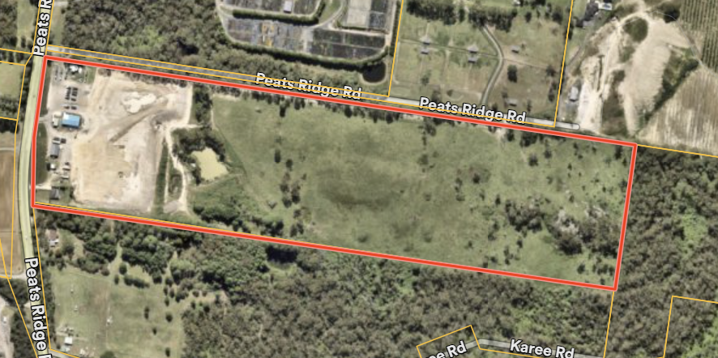
Figure 1. The site

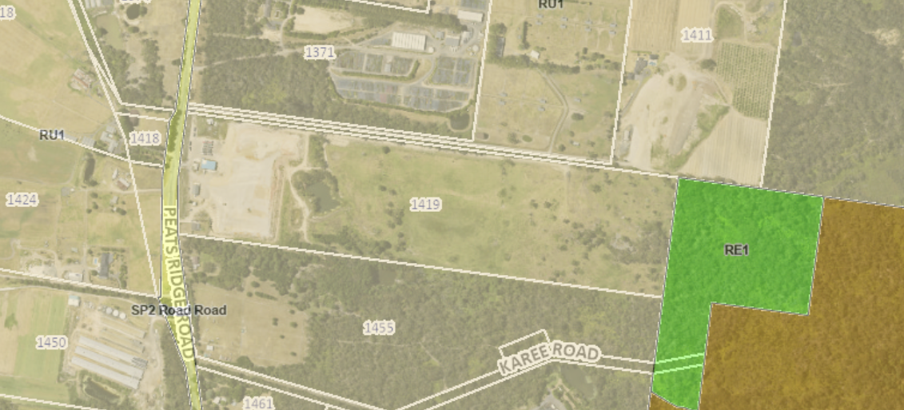
Figure 2. The zoning of the site

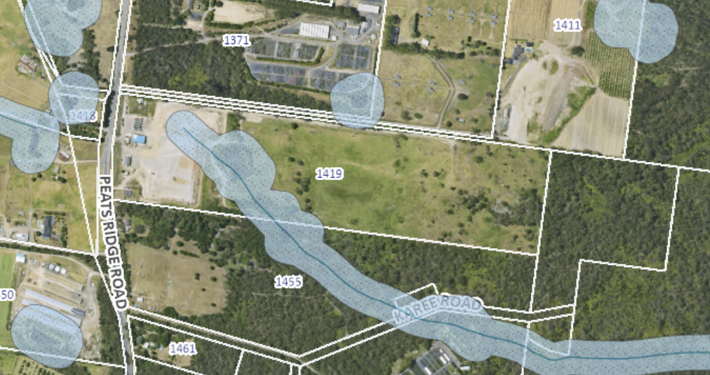
Figure 3. Mapped watercourse running through the site.

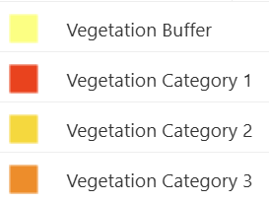
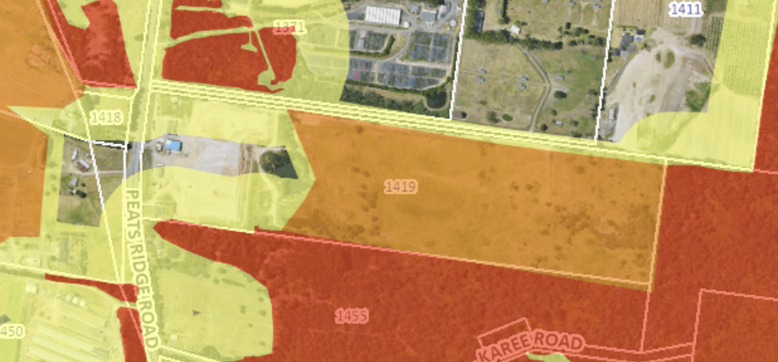
Figure 4. Bushfire risk to the site.

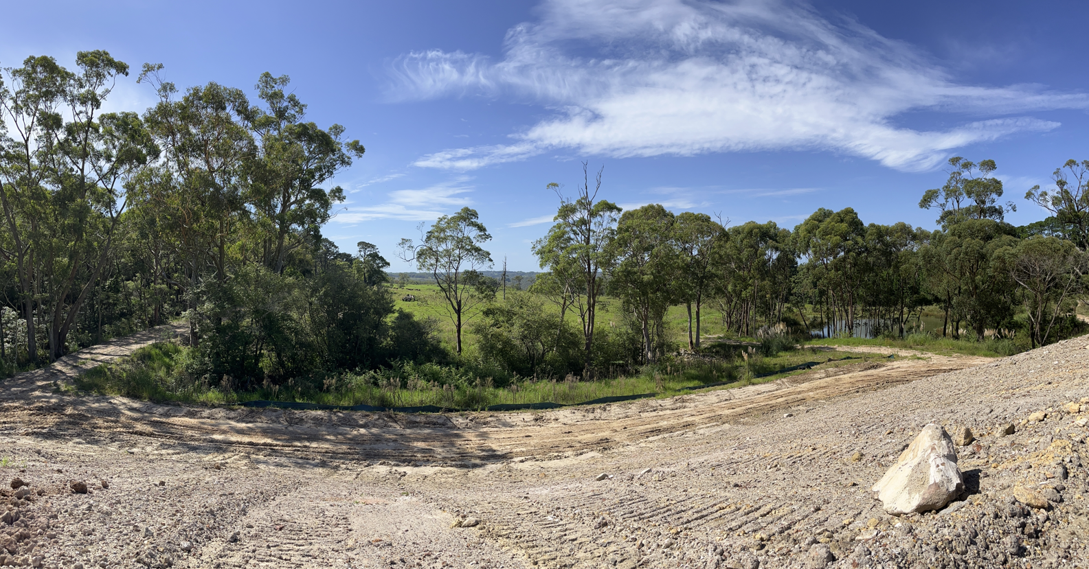
Figure 5. Development site looking east from existing fill pad.

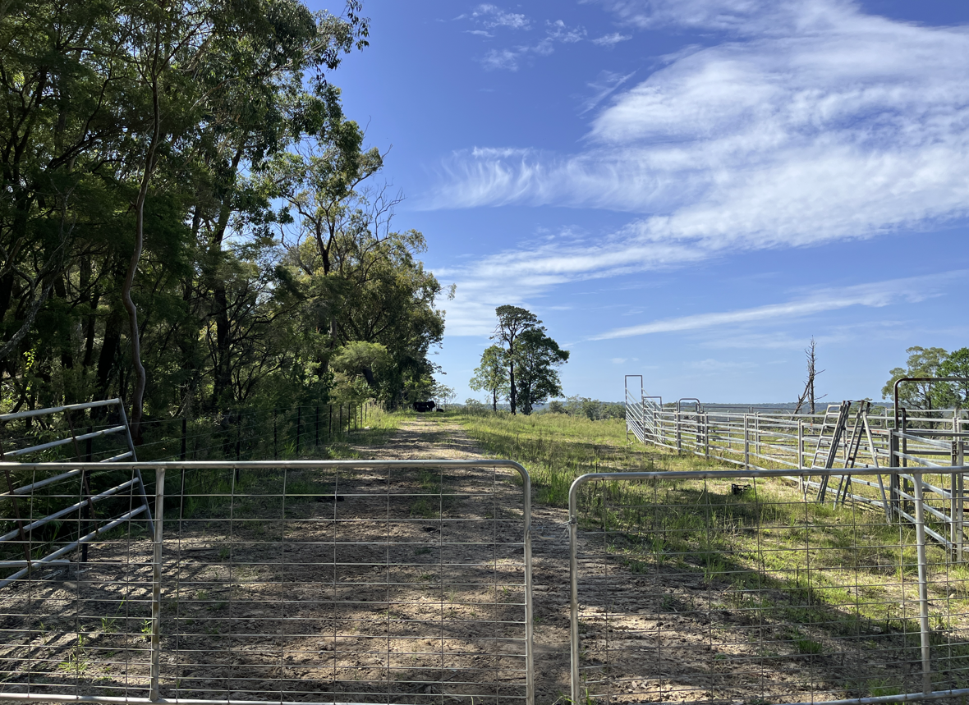
Figure 6. Northern boundary looking east.

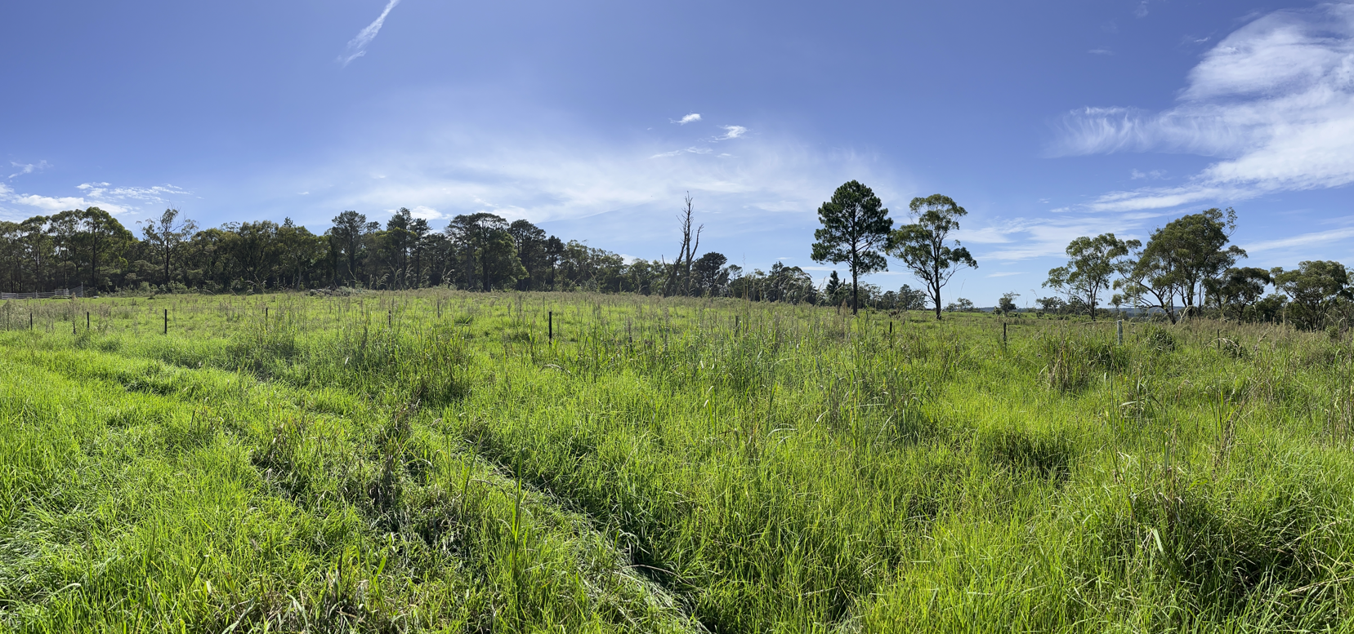
Figure 7. View of development area from south-west looking north-east.

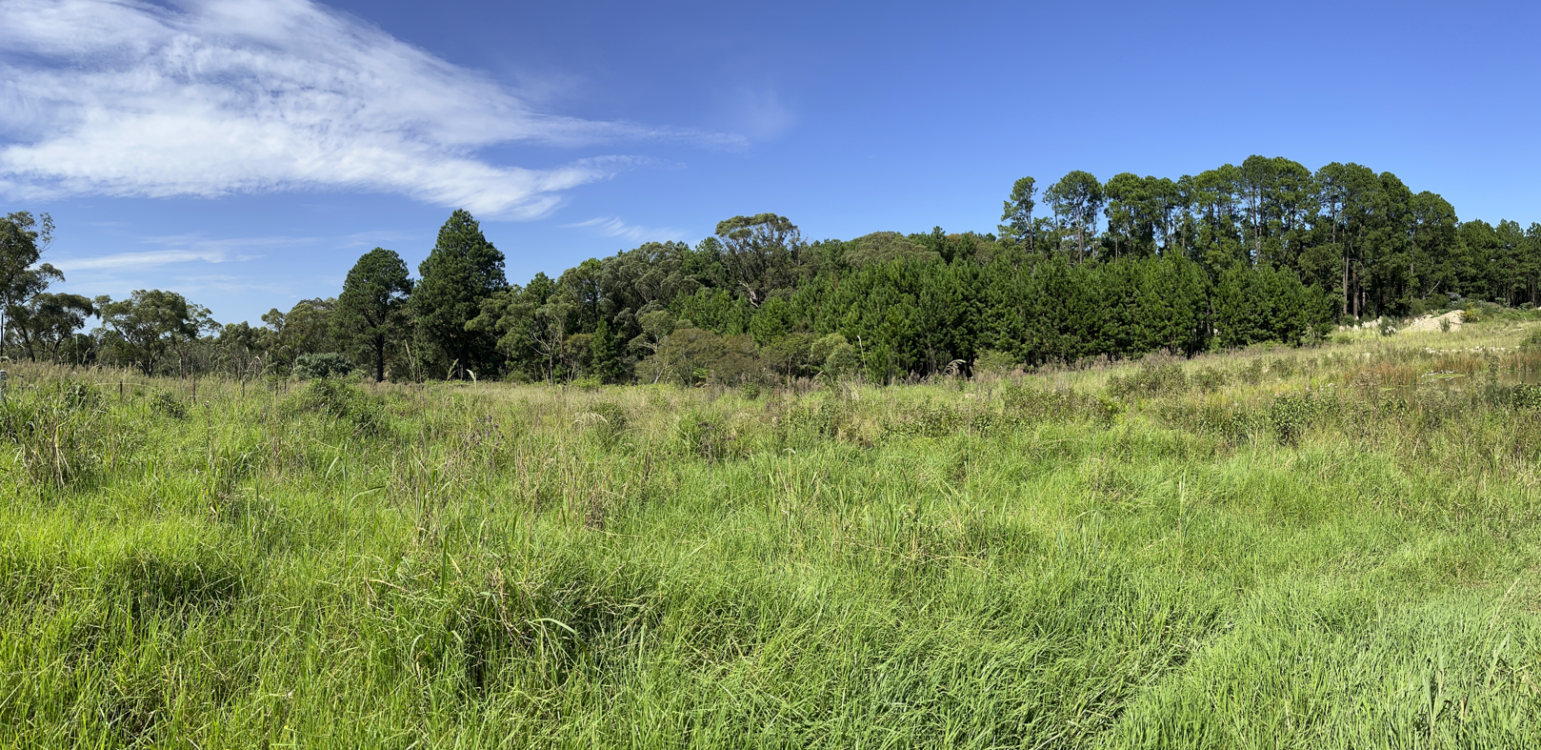
Figure 8. Looking to south of development area

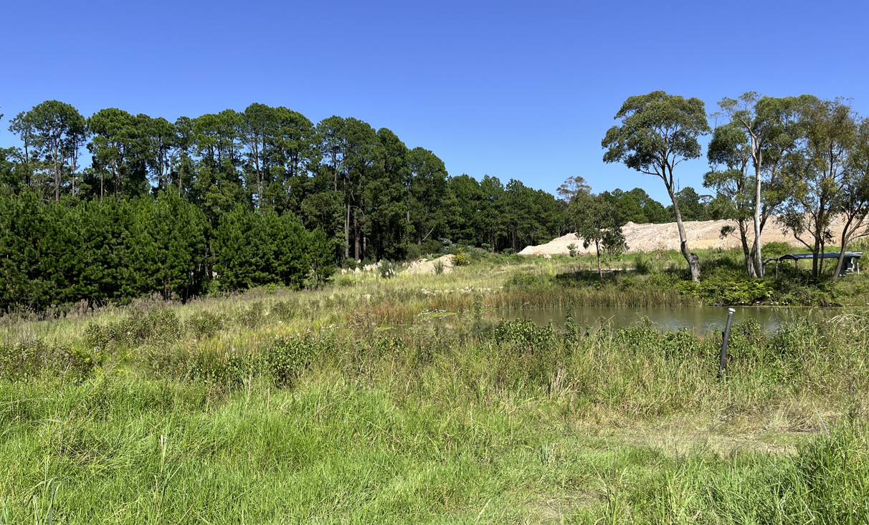
Figure 9. Existing dam looking west with existing fill pad in the distance.

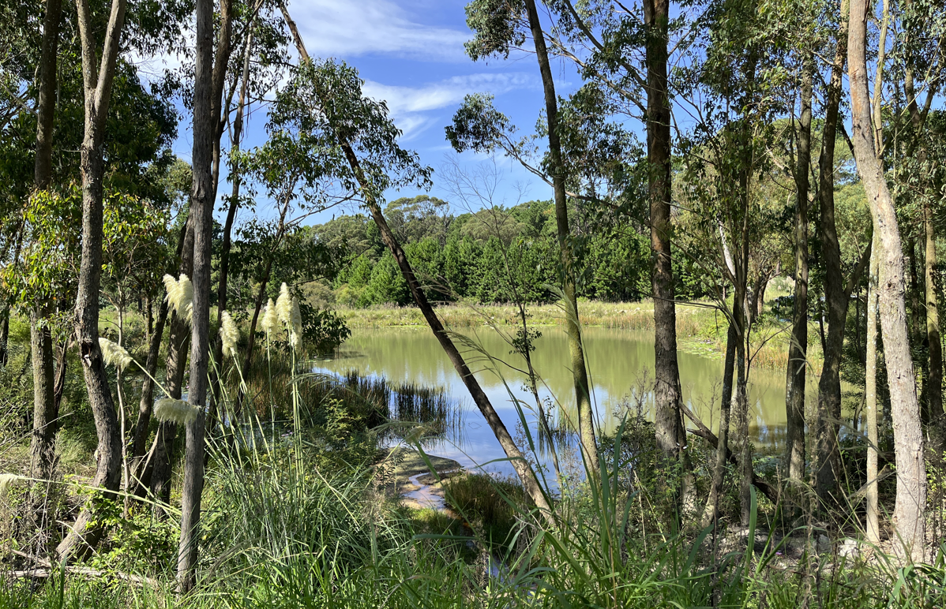
Figure 10. Existing dam looking south

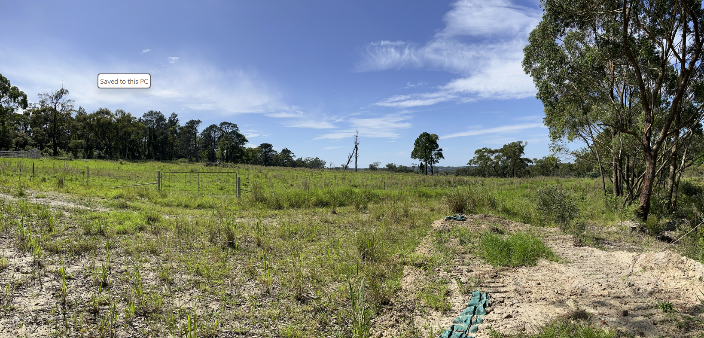
Figure 11. Looking east to development area

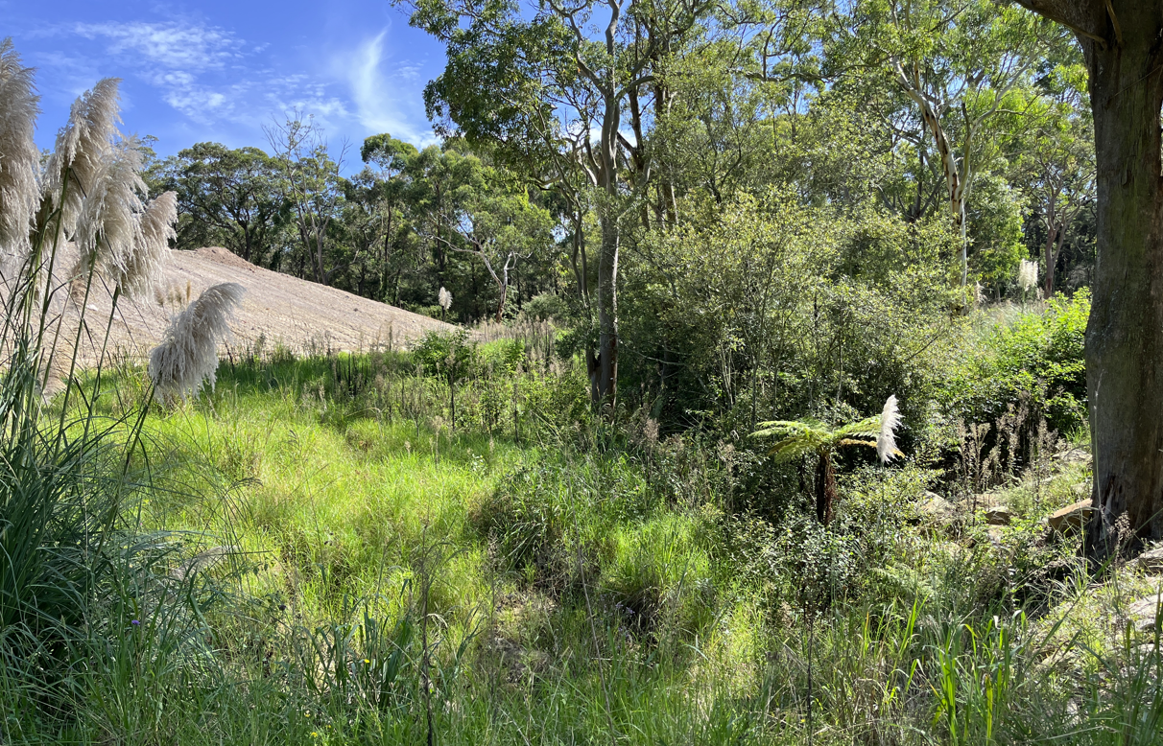
Figure 12. Existing watercourse area looking north with existing fill pad to the west.

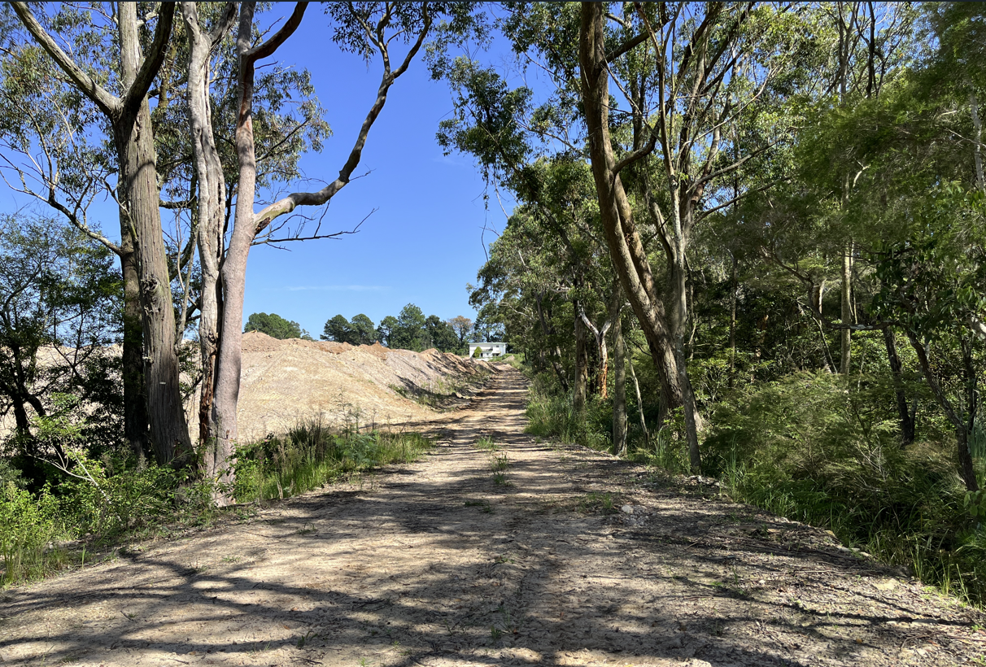
Figure 13. Existing access looking west.

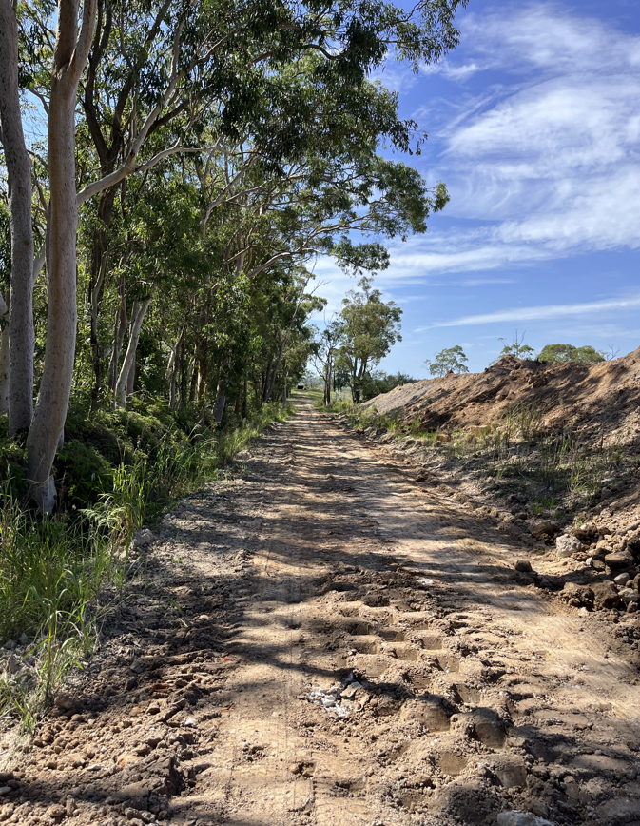
Figure 14. Existing unformed access looking east.

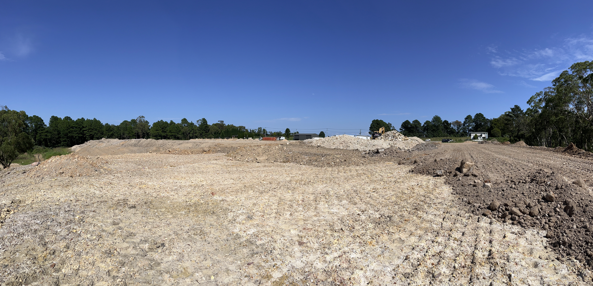
Figure 15. Existing fill pad at the front of the site looking south-west.

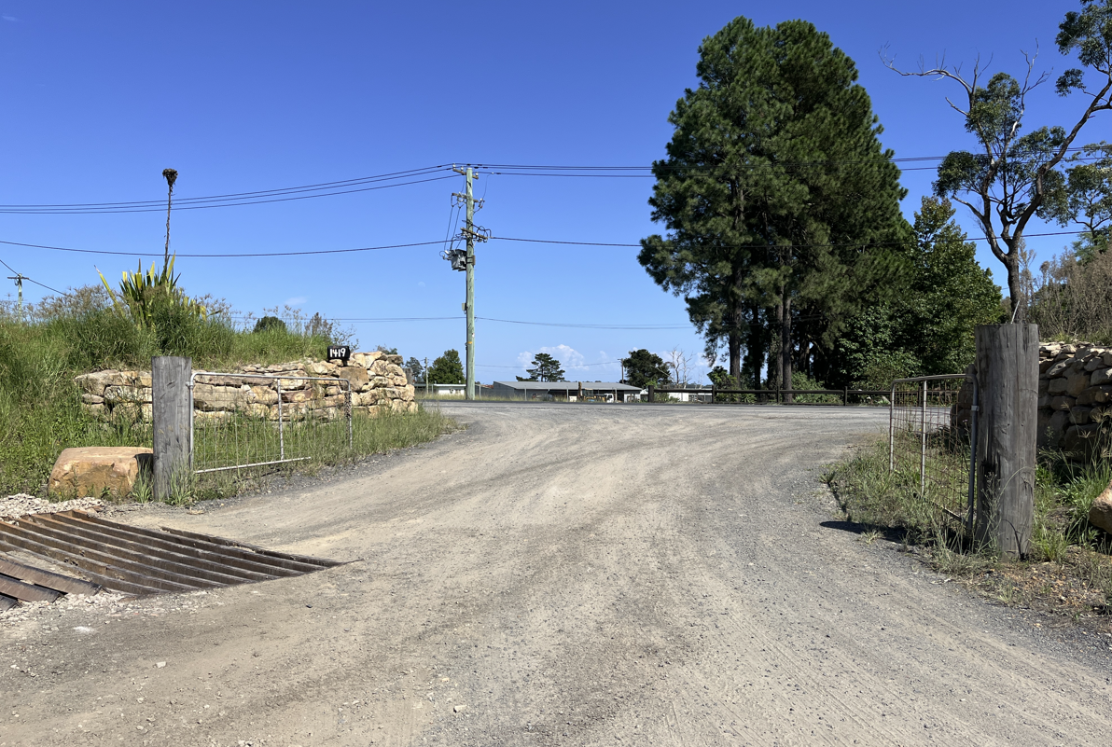
Figure 17. Existing site access looking west to Peats Ridge Road.

  - The Locality

The site is located within the Peats Ridge area of the Central Coast Plateau. The local area is dominated by extensive and intensive agricultural uses of varying scales. The local area also contains large spans of native vegetation located within National Parks, state forests and other reserves.

The lots immediately adjoining the site are utilised for primary production purposes with a nursery to the north along with a horse establishment. Land to the west contains a poultry farm, crops and greenhouse developments. Land to the south consists of largely grazing lots with substantial existing vegetation. Land to the east forms part of a National Park with Mooney Mooney Creek located further to the east.

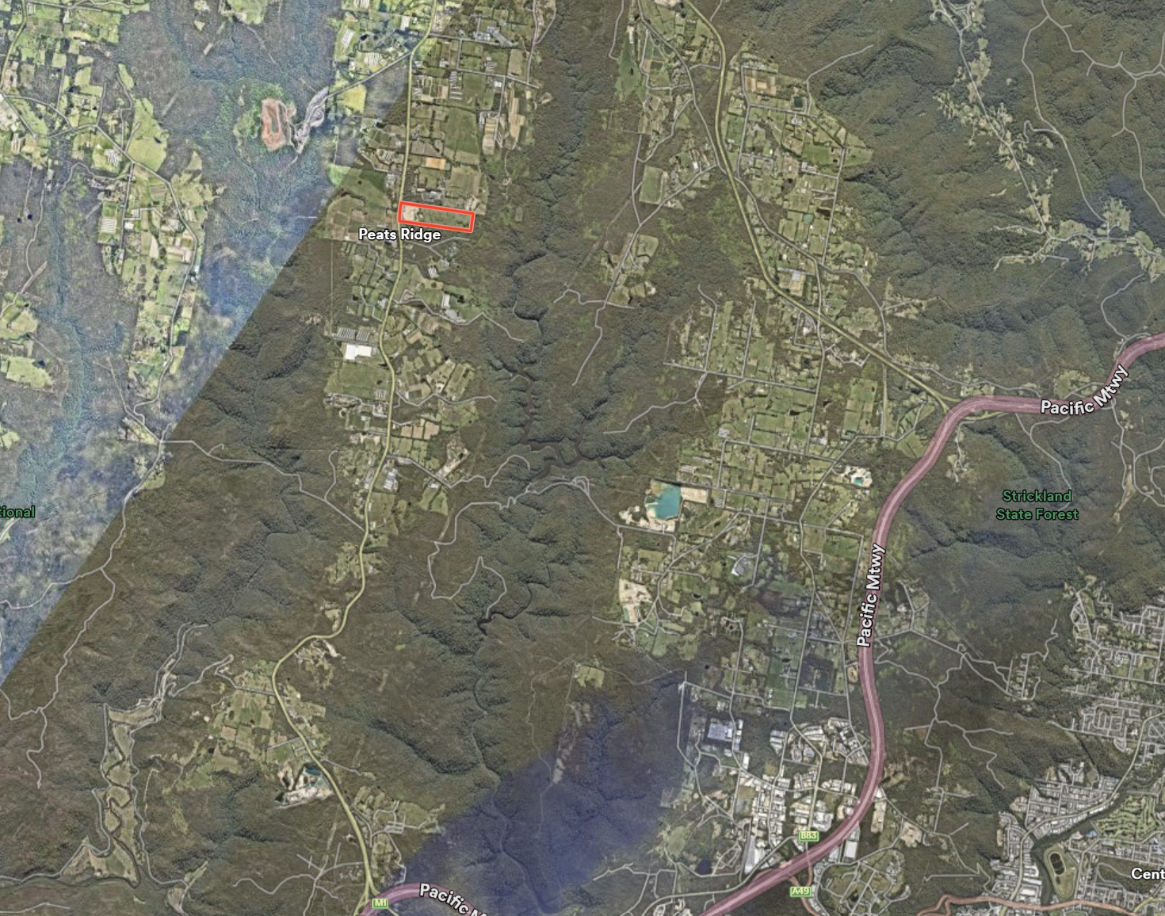
Figure 18. The site within the broader Central Coast Plateau locality.

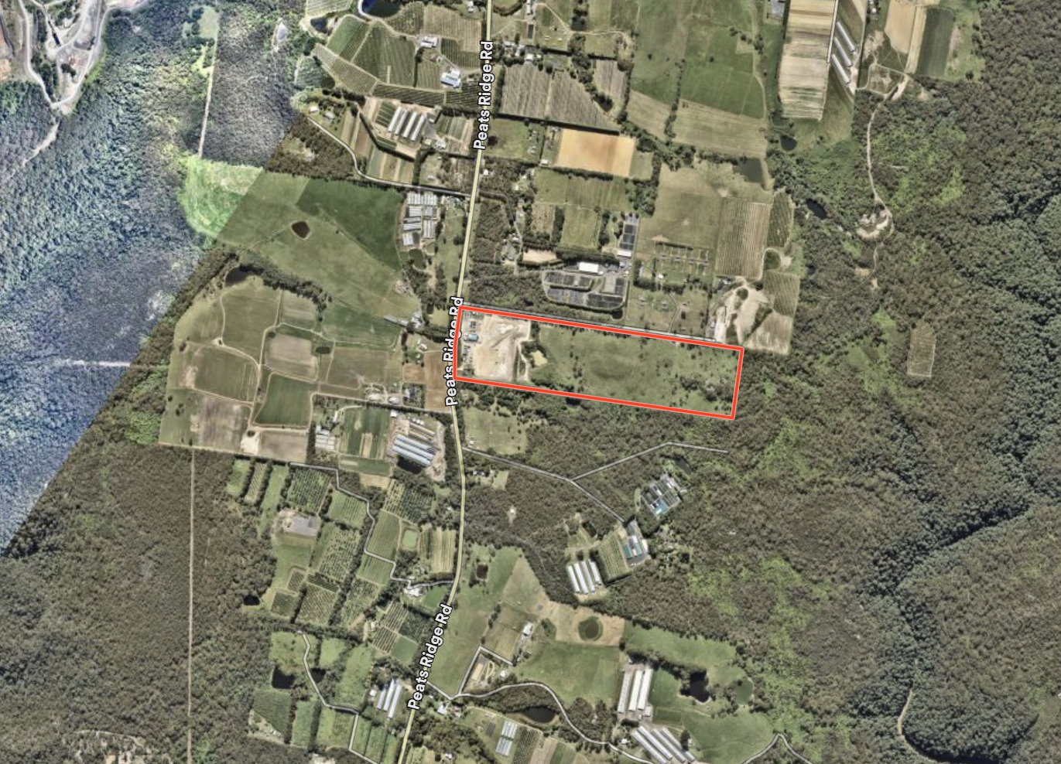
Figure 19. The site within the immediate locality.

- THE PROPOSAL AND BACKGROUND

  - The Proposal

The proposed development is for the construction and operation of a new greenhouse development on the site.

The proposed development will be undertaken within the central portion of the site and will include the following works:

- Clearing of existing vegetation. The proposal will require the removal of 134 trees that are located both within the development footprint and within the area of the existing water course and dam. Some trees that would also be impacted by filling activities would also be required to be removed.

- Creation of a fill pad within the central portion of the site. The proposed filled area will cover around 7.5 hectares of the site. The fill pad will be constructed utilising approximately 500,000m³ of fill and would vary between natural ground level and a maximum height of 15 metres.

The proposed filling is to be undertaken utilising a mixture of VENM (Virgin excavated natural material), ENM (Excavated natural material) or fines removed from tunnel works generally within the metropolitan areas of Sydney. The fill is also be derived from approved development sites generally within the Central Coast region.

The proposed pad will be supported by batters at a 2:1 slope and will incorporate rock protection. A three-metre-wide offset is to be provided between the base of the fill and the boundary.

The construction of the fill pad is to be undertaken over an 18-month period as and when fill materials are available. As each delivery arrives at the site it will be checked and if suitable will be spread across the site and compacted. Unsuitable materials would be rejected and sent back to the source. At the completion of each day material is to be sealed off to ensure stockpiles are not left to slump on the site overnight.

- The driveway along the northern boundary will be upgraded to an all-weather trafficable surface consisting of compacted and stabilised gravel. The proposed driveway will also be provided with passing opportunities not exceeding 200 metres. The driveway will extend to the development site and will link into a link road around the greenhouse structure and a small parking area is to be provided adjacent to the greenhouses on the western elevation.

- Works will be undertaken to expand the existing dam. The walls of the existing dam will be raised, and the footprint of the dam will also be expanded to increase the capacity of the dam for farm use. Works to the dam will also include the provision of a permanent sediment basin and construction of a new dam overflow spillway that will direct the water to a grassed swale at the south of the property.

- Construction of a greenhouse structure with a total area of 35,145m². The proposed structure will be located within the centre of the newly constructed fill pad. The greenhouse will be a total of 300 metres long and 117m metres wide. The structure would have a maximum height of 7.8 metres and would consists of 11 rows of dome roofing. The structure is to be constructed out of poly carbonate materials.

The greenhouses will be setback 50 metres from the northern boundary and 71 metres to the southern boundary. The greenhouse will be located almost 430 metres from the front boundary and just over 200 metres from the rear boundary. A heavy rigid vehicle track will be provided around the exterior of the building.

The proposed greenhouses will be utilised for the purposes of horticulture and operated by five staff and would be in operation 24 hours per day, seven days per week. Deliveries of materials to the site would be limited to a few times a week whilst the export of products would be via two semi-trailers per week which would be loaded and leave the site in the evening for predominantly Sydney markets.

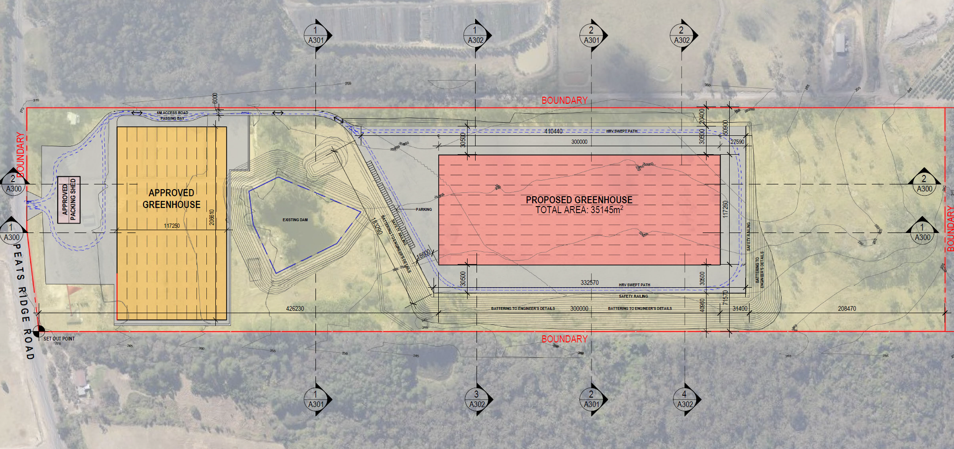
Figure 20. Proposed location of fill pad and greenhouse building

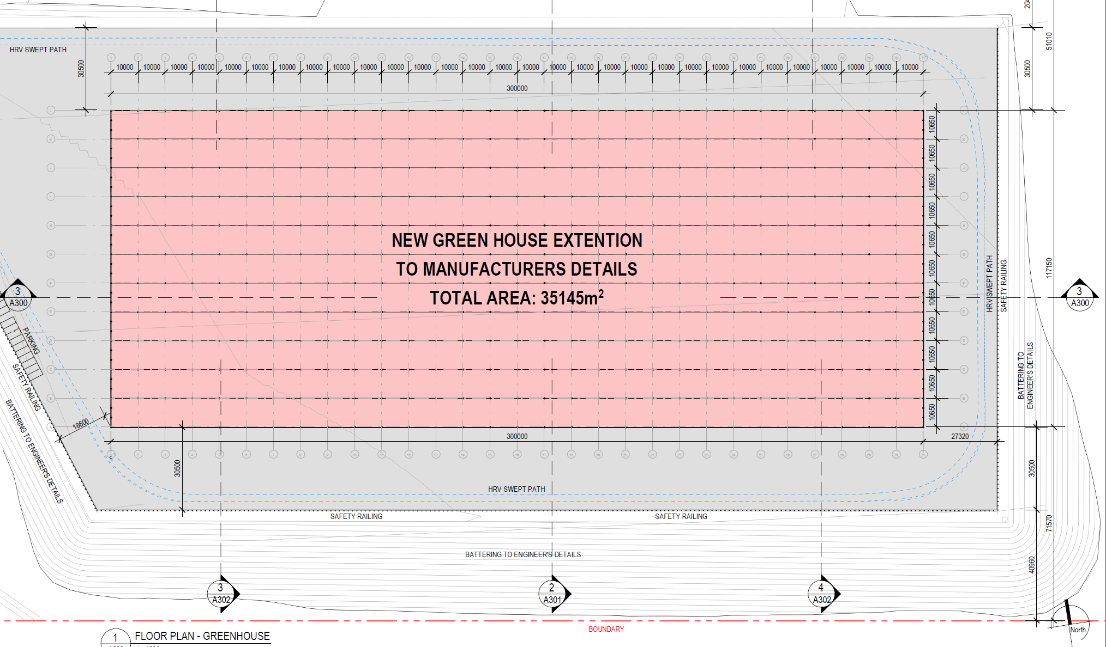
Figure 21. Proposed greenhouse building.

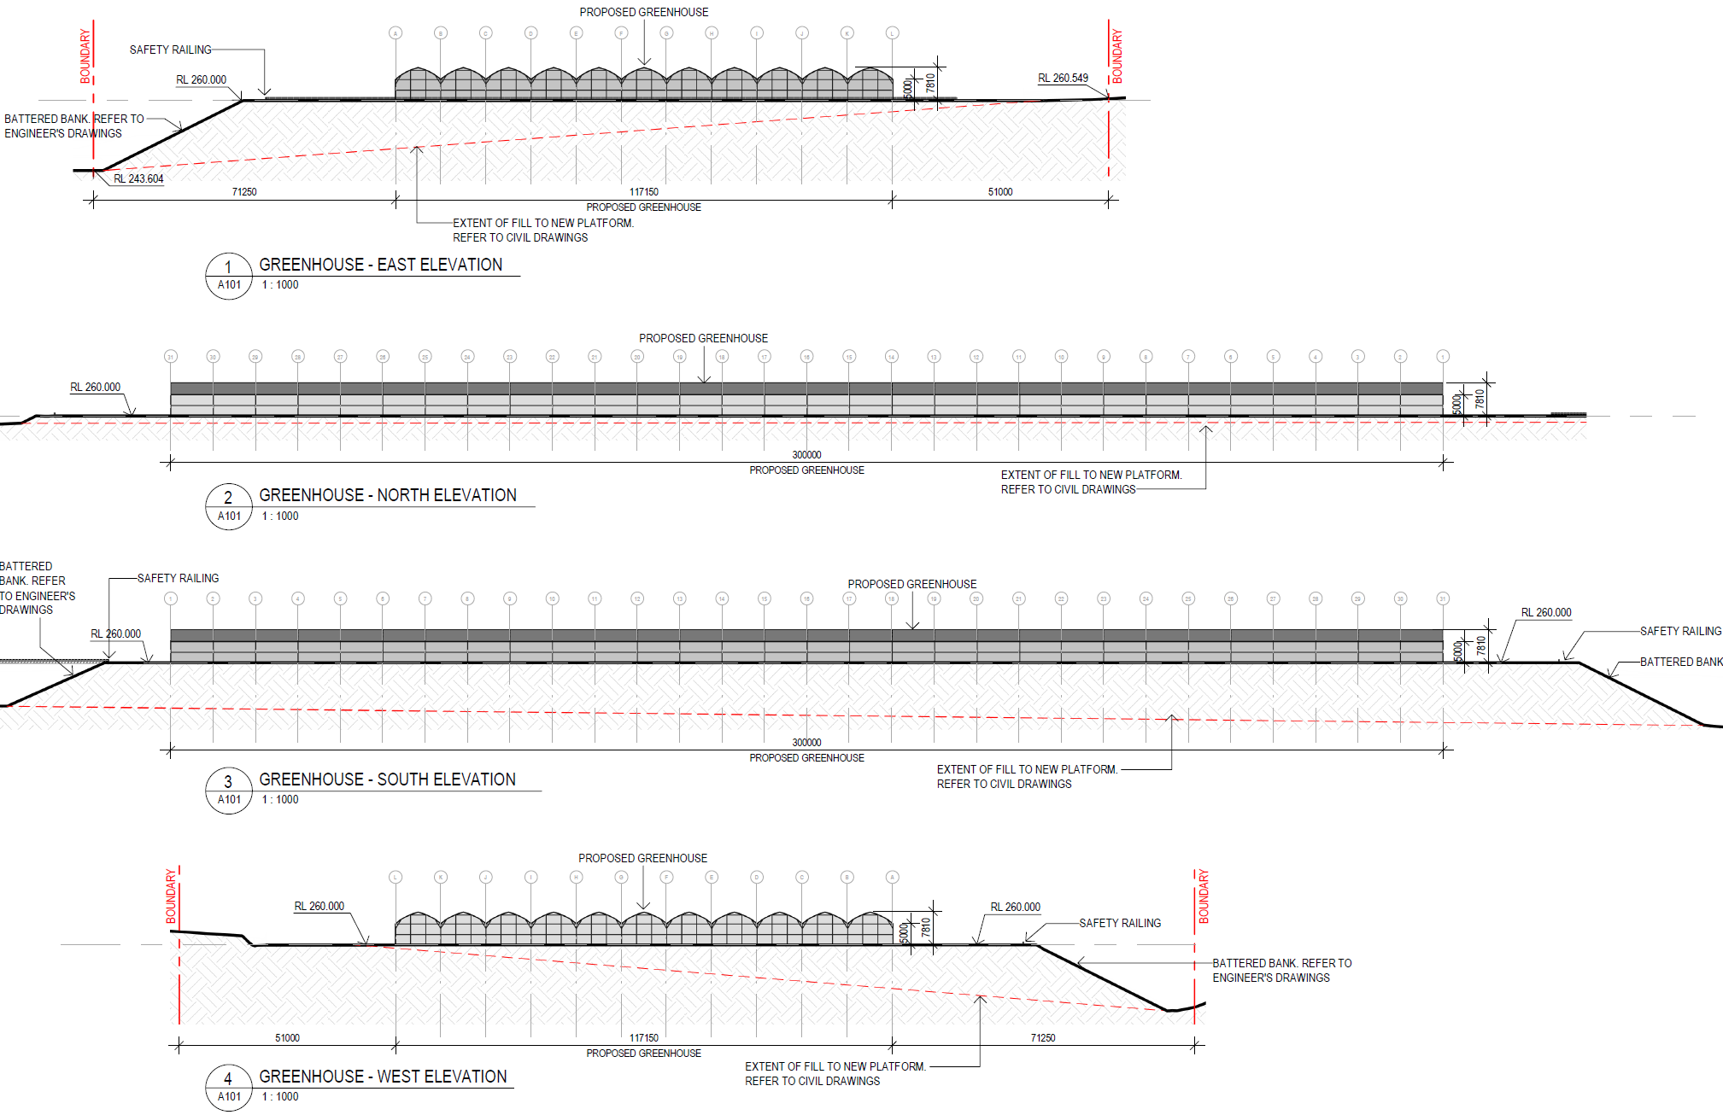
Figure 22. Proposed elevations of greenhouse and fill pad.

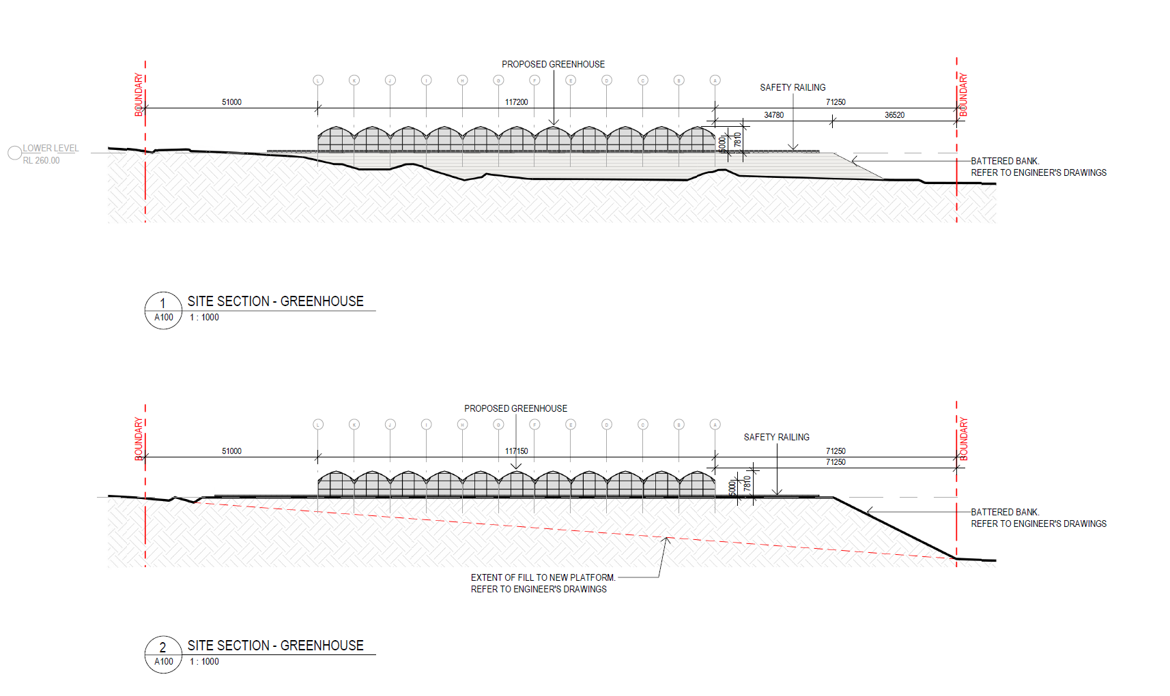
Figure 23. Proposed sections of greenhouse and fill pad.

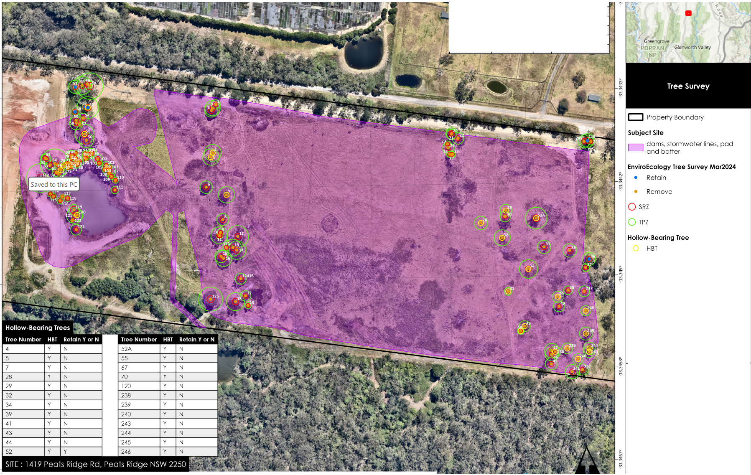
Figure 24.Tree survey of site showing trees to be removed and retained.

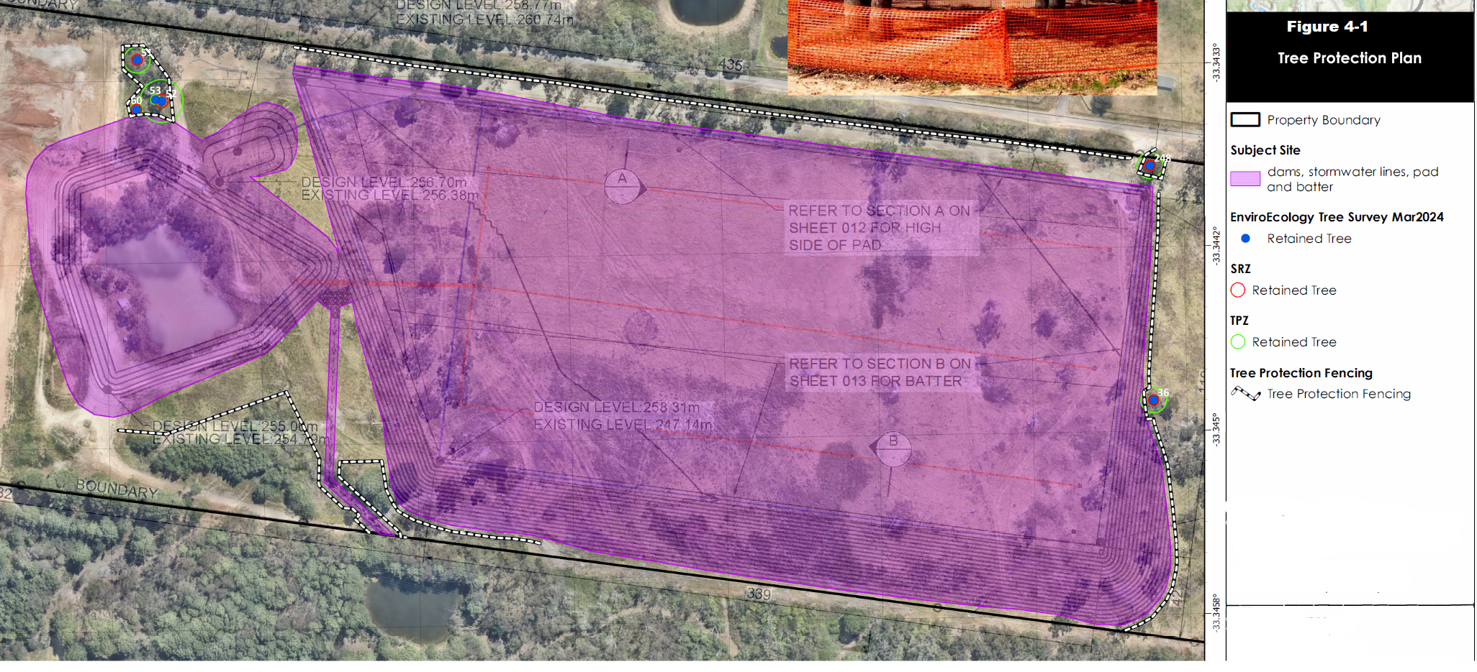
Figure 25. Proposed trees to be retained within the area of works.

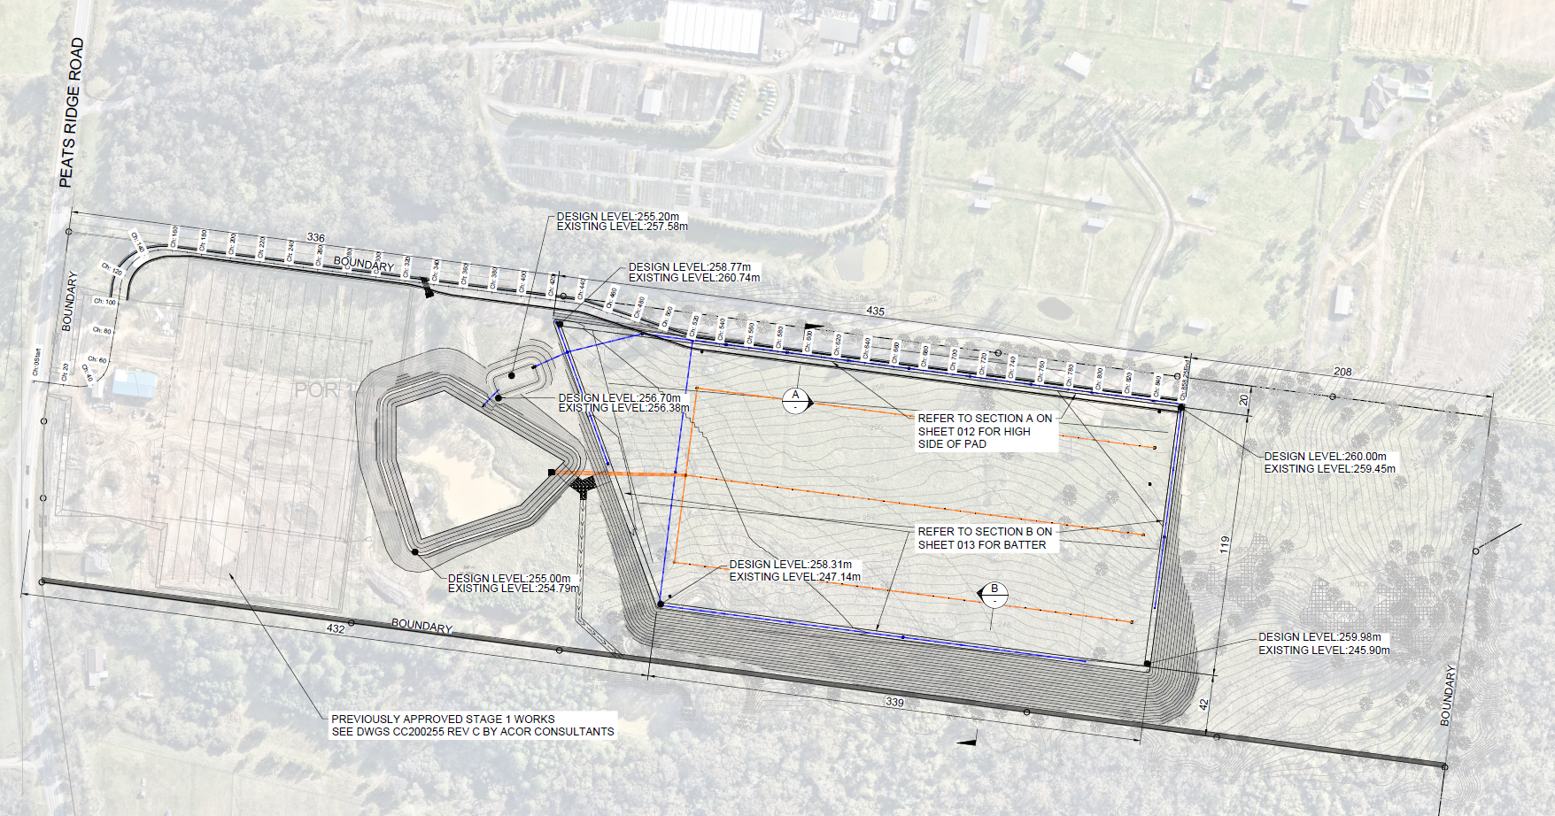
Figure 26. Proposed civil works to be undertaken on the site.

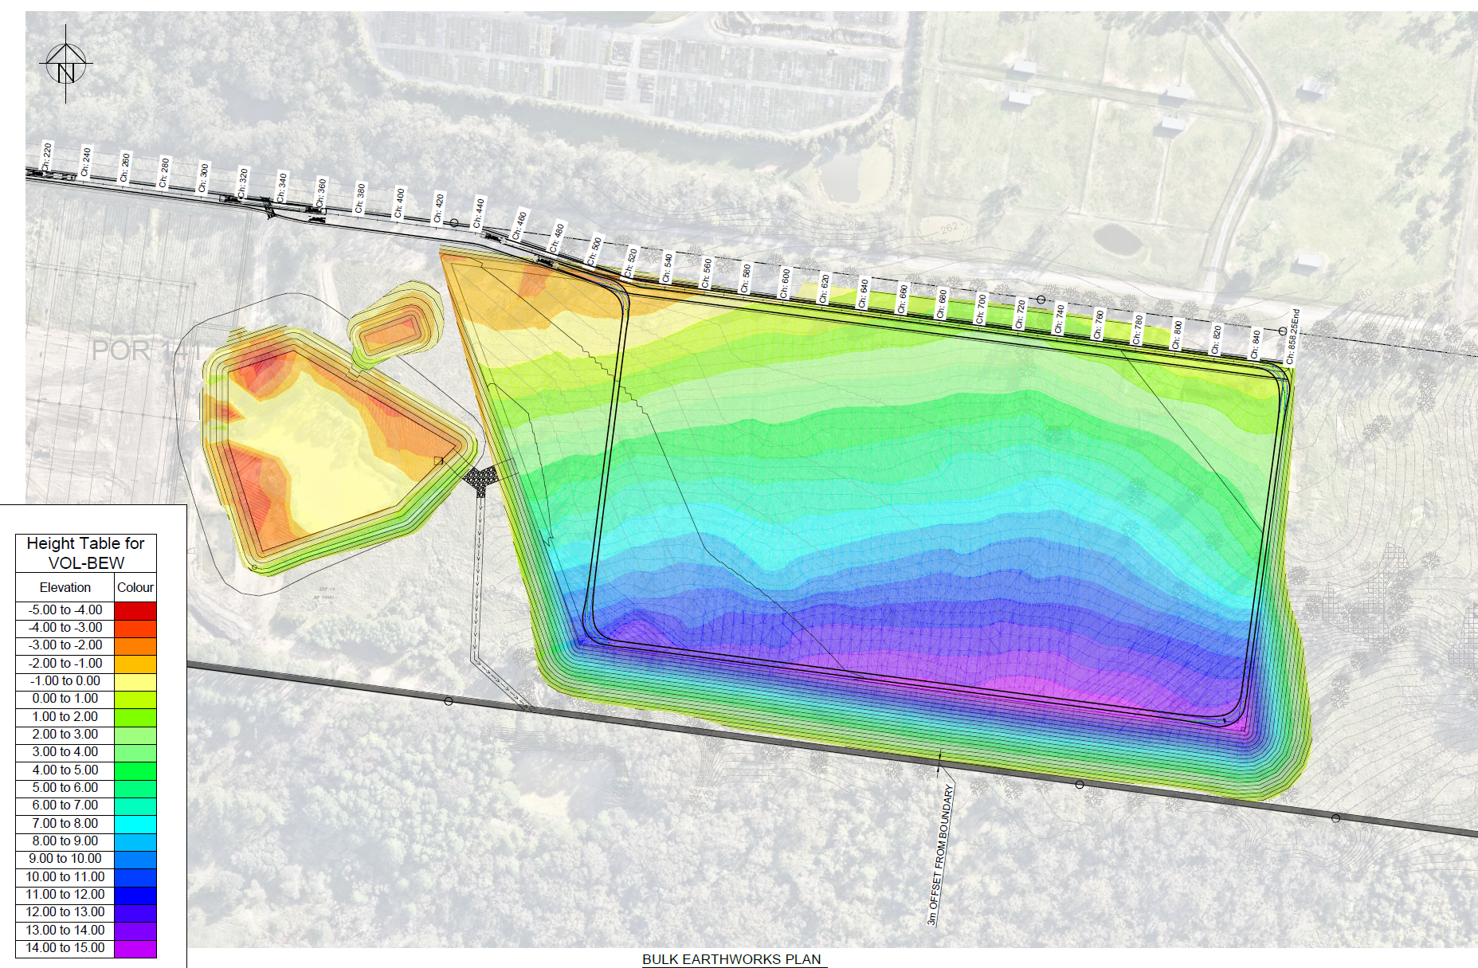
Figure 27. Proposed extent of cut and fill to be undertaken on the site.

Table 1: Development Data
Control | Proposal
Site area | 23.27 hectares
Clause 4.6 Requests | N/A
Setbacks | Building: 430m front, 50m north, 70m south and 200 rear  Fill pad: 200m front, 20m north, 3m south and 175m rear

  - Background

The development application was lodged on 2 October 2024. A chronology of the development application since lodgement is outlined below including the Panel’s involvement (briefings, deferrals etc) with the application:

Table 2: Chronology of the DA
Date | Event
2 October 2024 | DA lodged
1 November 2024 | Exhibition of the application
23 October 2024 | DA referred to external agencies
25 March 2025 | Panel briefing
8 April 2025 | Request for Information from Council to applicant
30 June 2025 | Amended information provided: Stormwater Plan, Engineering drawings, updated architectural plans, Traffic Report, Air Quality Assessment, Acoustic Report, SEPP assessment
7 July 2025 | Amended information provided: RFI response and waste management plan.
23 July 2025 | Amended information provided: Ecologist response
18 August 2025 | Request for information from Council to applicant
12 September 2025 | Amended information provided: Bushfire Statement
25 September 2025 | Amended information provided: RFI response, Soil and Water Management Plan, Civil Engineering Plans, Updated Bushfire Report, Acoustic Report
30 September 2025 | Amended information provided: Acoustic Report, Air Quality Impact Assessment, Addendum to Noise Impact Assessment, Updated Architectural Plans

  - Site History

Council’s records show the following history of applications relevant to the site:

Application No. | Description | Decision | Decision Date
DA/809/2024 | Intensive Agriculture | Returned | N/A
DA/490/2024 | Intensive Agriculture | Returned | N/A
DA/2252/2023 | Intensive Agriculture | Returned | N/A
DA/54735/2018A | Greenhouse, packing shed and amenities building | 6 March 2020 | Approved
DA/54735/2018 | Greenhouse, packing shed and amenities building | 6 March 2019 | Approved
DA27562/2005 | Intensive Agriculture |  | Surrendered

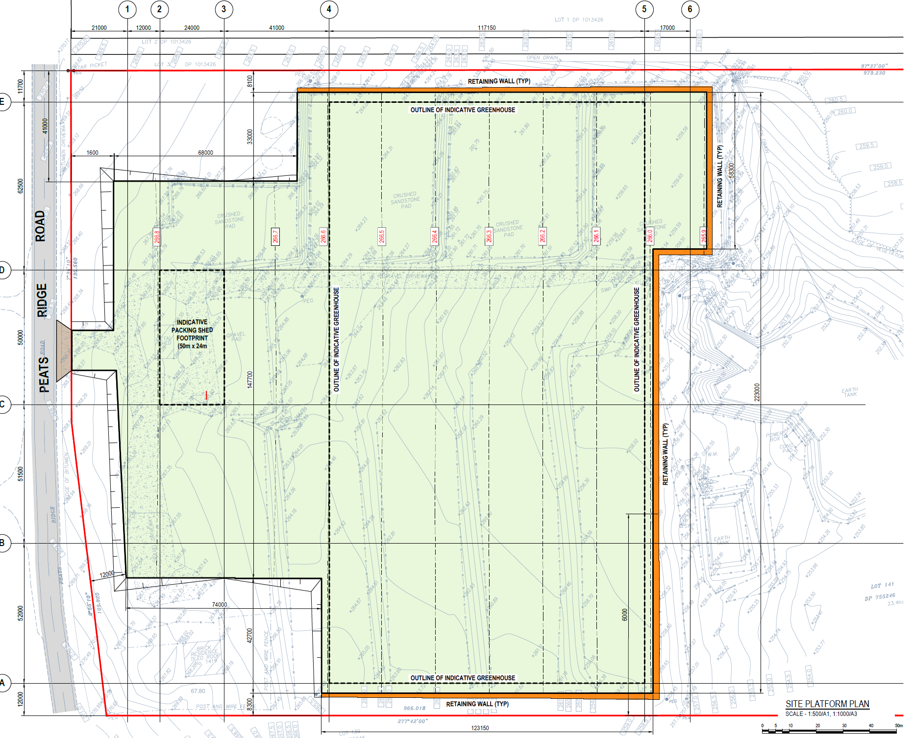
Figure 28. Greenhouse, packing shed and amenities building (with fill pad and retaining walls) approved at the front of the site.

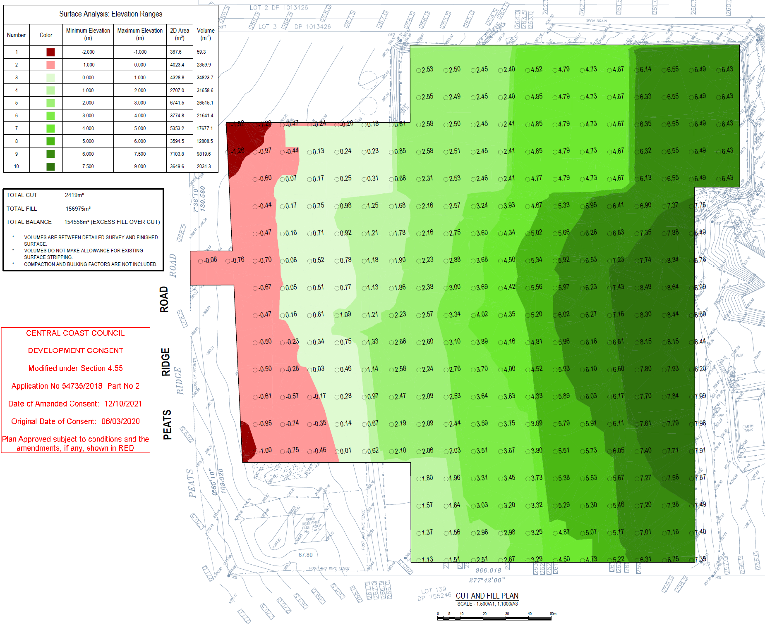
Figure 29. Fill pad approved under DA/54735/2018/A

The building pad associated with DA54735/2018/A incorporates cut of around one metre with filling up to 9 metres requiring around 150,000m³ of fill. Site preparation work associated with the existing consent appear to be near completion with final levelling and construction of approved retaining structures and greenhouses remaining incomplete.

- STATUTORY CONSIDERATIONS

When determining a development application, the consent authority must take into consideration the matters outlined in Section 4.15(1) of the Environmental Planning and Assessment Act 1979 (‘EP&A Act’). These matters as are of relevance to the development application include the following:

- the provisions of any environmental planning instrument, proposed instrument, development control plan, planning agreement and the regulations
(i) any environmental planning instrument,
(ii) any proposed instrument that is or has been the subject of public consultation under this Act and that has been notified to the consent authority (unless the Planning Secretary has notified the consent authority that the making of the proposed instrument has been deferred indefinitely or has not been approved), and
(iii) any development control plan, and
(iiia) any planning agreement that has been entered into under section 7.4, or any draft planning agreement that a developer has offered to enter into under section 7.4, and
(iv) the regulations (to the extent that they prescribe matters for the purposes of this paragraph),
that apply to the land to which the development application relates,
- the likely impacts of that development, including environmental impacts on both the natural and built environments, and social and economic impacts in the locality,
- the suitability of the site for the development,
- any submissions made in accordance with this Act or the regulations,
- the public interest.

The proposal is;

- Integrated Development (s4.46)
- Requiring concurrence/referral (s4.13)

  - Environmental Planning Instruments, proposed instrument, development control plan, planning agreement and the regulations

The relevant environmental planning instruments, proposed instruments, development control plans, planning agreements and the matters for consideration under the Regulation are considered below.

- Section 4.15(1)(a)(i) - Provisions of Environmental Planning Instruments

The following Environmental Planning Instruments are relevant to this application:

- State Environmental Planning Policy (Planning Systems) 2021
- State Environmental Planning Policy (Primary Production) 2021
- State Environmental Planning Policy (Resilience and Hazards) 2021
- Central Coast Local Environmental Plan 2022;

A summary of the key matters for consideration arising from these State Environmental Planning Policies are outlined in Table 3 and considered in more detail below.

Table 3: Summary of Applicable Environmental Planning Instruments

EPI | Matters for Consideration | Comply (Y/N)
State Environmental Planning Policy (Planning Systems) 2021 | Chapter 2: State and Regional Development  - Section 2.19(1) declares the proposal regionally significant development pursuant to Clause 2 of Schedule 6 as it comprises General Development over $30 million. | Y
State Environmental Planning Policy (Primary Production) 2021 | - Chapter 3: Central Coast Plateau Areas | No
Proposed Instruments | No compliance issues identified. | Yes
LEP | - Clause 2.3 – Permissibility and zone objectives | No
DCP | - CCDCP 2022, Chapter 2.6 – Commercial Hydroponics | No

Consideration of the relevant SEPPs is outlined below

- State Environmental Planning Policy (Planning Systems) 2021 (‘Planning Systems SEPP’)

Chapter 2: State and Regional Development

The proposal is regionally significant development pursuant to Section 2.19(1) as it satisfies the criteria in Clause 2 of Schedule 6 of the Planning Systems SEPP as the proposal is general development with an estimated development cost of more than $30 million. Accordingly, the Hunter Central Coast Regional Planning Panel is the consent authority for the application.

- State Environmental Planning Policy (Primary Production) 2021

Chapter 3: Central Coast plateau areas
The proposal is captured by the above chapter given the site’s location within the Central Coast Plateau Area. The aims of the chapter are as follows:

(a) to provide for the environmental protection of the Central Coast plateau areas and to provide a basis for evaluating competing land uses,
(b) to encourage the use of land having a high agricultural capability for that purpose and, as much as possible, to direct development for non-agricultural purposes to land of lesser agricultural capability,
(c) to protect regionally significant mining resources and extractive materials from sterilization,
(d) to enable development for the purposes of extractive industries in specified locations,
(e) to protect the natural ecosystems of the region, and
(f) to maintain opportunities for wildlife movement across the region, and
(g) to discourage the preparation of draft local environmental plans designed to permit rural residential development, and
(h) to encourage the preparation of draft local environmental plans based on merits.

The proposal would result in the expansion of an agricultural use on the site. The land is not considered to be suitable for the proposed development given the extent of and impacts associated with the site works required to address the constraints of the site. The requirement for a significant amount of fill on the site to produce a level platform would suggest that the existing site conditions are not compatible with the development proposed.

The rear of the site that contains indigenous items of significance which could be maintained and there is potential for the rear site to be enhanced via vegetation management and plantings which would build on the adjoining natural areas and promote wildlife movement across the site.

The front of the site has an existing approved greenhouse agricultural use. The proposal would expand this through the creation of an additional greenhouse development on the site however, as mentioned the siting of the proposed development results in undue impacts. Given the size of the structure proposed to be located on the site the agricultural use would be a more intensive agricultural use than the existing cattle grazing undertaken on the site.

Although the proposal would result in the use of prime agricultural land for an agricultural use it would require extensive works on the site and the removal of a large number of trees. The proposal would therefore not be consistent with the objectives of Chapter 3 of the SEPP as the proposed agricultural use is not compatible with the existing constraints of the site.

- State Environmental Planning Policy (Resilience and Hazards) 2021

Chapter 4: Remediation of Land

The provisions of Chapter 4 of State Environmental Planning Policy (Resilience and Hazards) 2021 (‘the Resilience and Hazards SEPP’) have been considered in the assessment of the development application. Section 4.6 of Resilience and Hazards SEPP requires the consent authority to consider whether the land is contaminated, and if the land is contaminated, it is satisfied that the land is suitable in its contaminated state (or will be suitable, after remediation) for the purpose for which the development is proposed to be carried out.

The proposed development is not a change of use from a use specified in subsection (4), and as such, the development is not subject to the provisions of 4.6(2) (Contamination and remediation to be considered in determining development application) of the State Environmental Planning Policy (SEPP) (Resilience and Hazards) (2021);
(2) ‘Before determining an application for consent to carry out development that would involve a change of use on any of the land specified in subsection (4), the consent authority must consider a report specifying the findings of a preliminary investigation of the land concerned carried out in accordance with the contaminated land planning guidelines.’

Historical imagery (as shown below) does not directly indicate any contaminating activities as listed in Table 1 to the contaminated land planning guidelines. Historical imagery indicates that the subject land has existed as a cleared vacant parcel of land used for grazing of cattle.

DA54735/2018 Part 1 comments from the Environmental Health Officer indicated that Asbestos Containing Material was present onsite during an inspection. A clearance Certificate was provided in response to a consent condition. Therefore, it is believed the subject land has not been subject to contamination from a previous land use, or purpose referred to in Table 1 of the “Contaminated Land Planning Guidelines” and no further assessment of contamination is required.

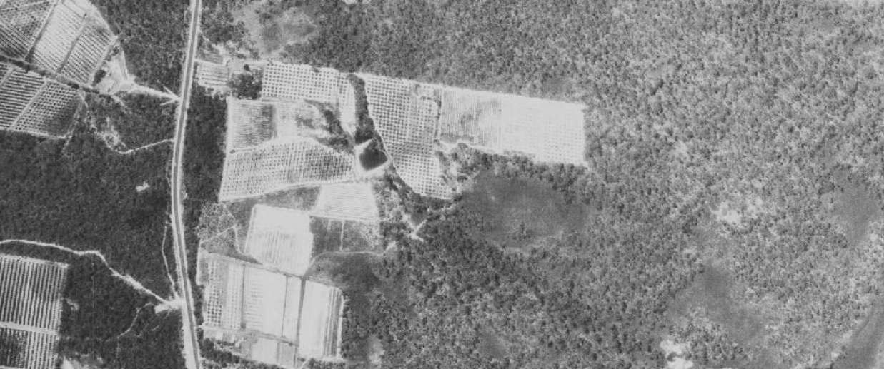
Figure 30. Aerial imagery of site 1966 (Source: NSW Government Historical Imagery)

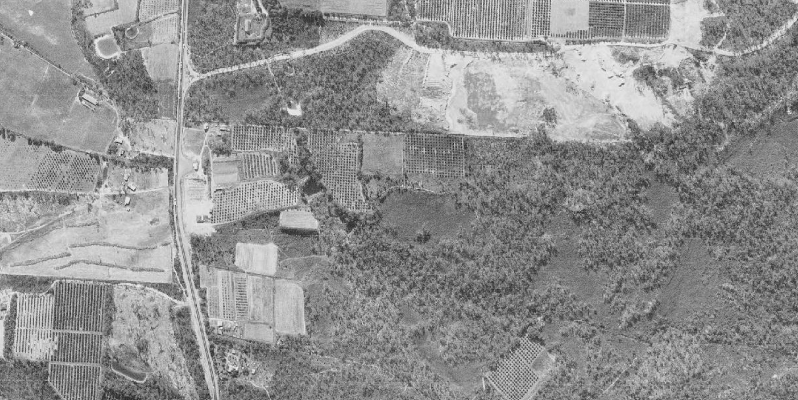
Figure 31. Aerial imagery of site 1975 (Source: NSW Government Historical Imagery)

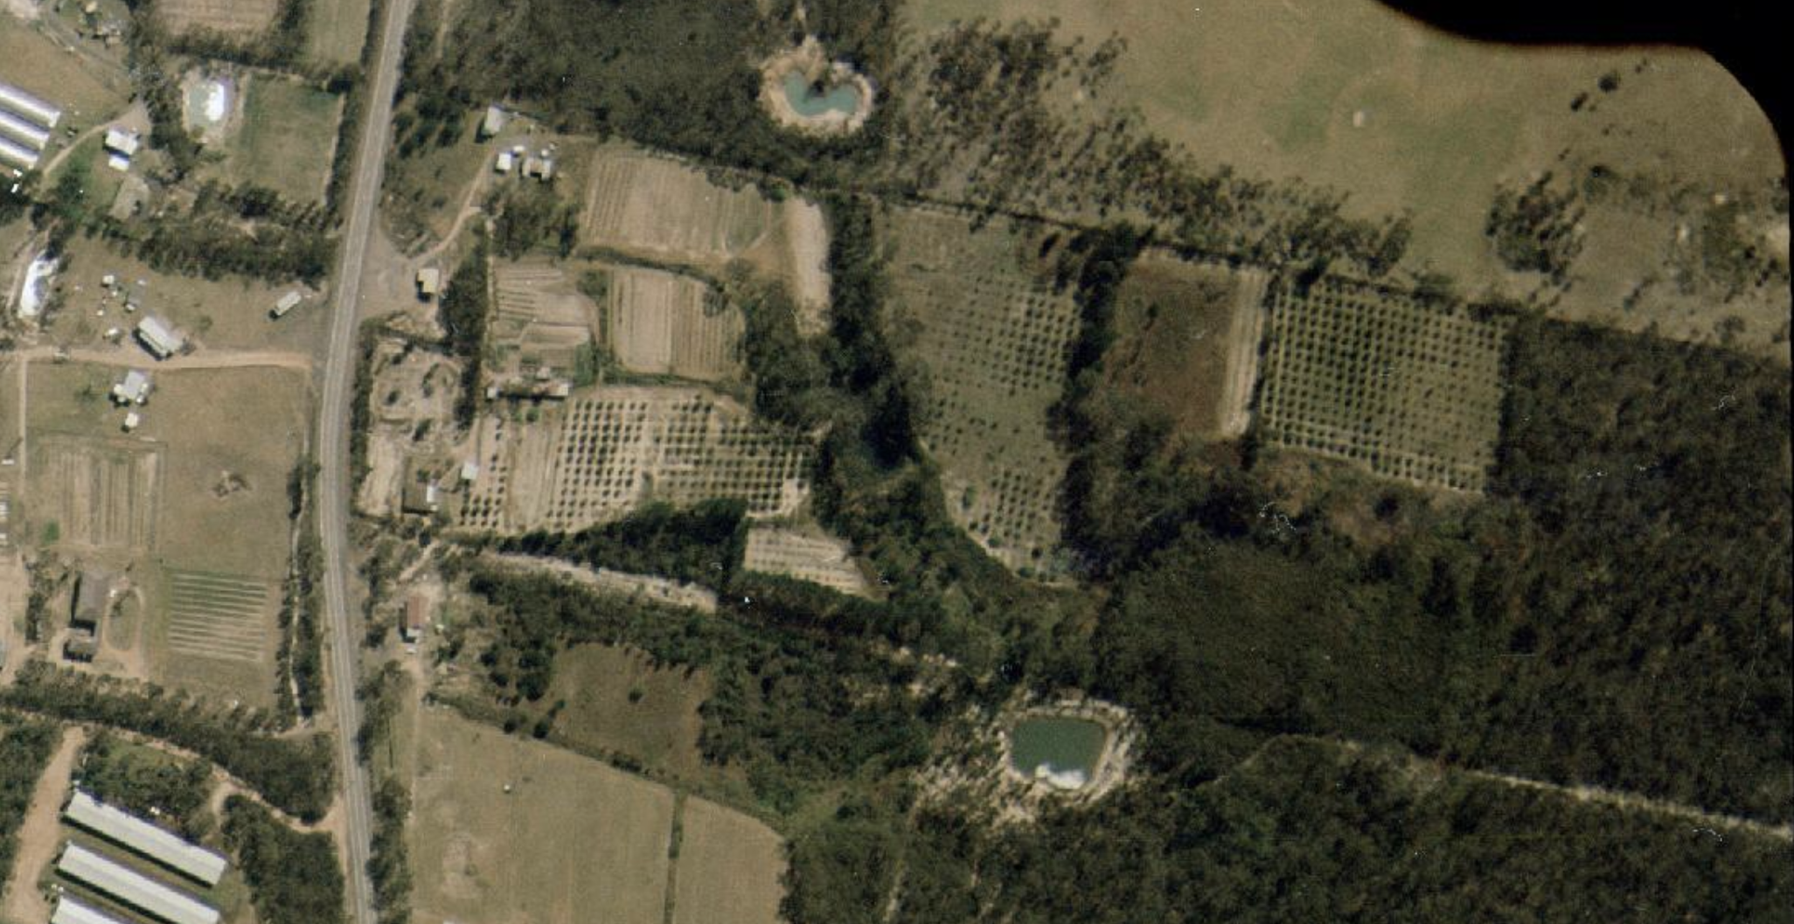 Figure 32. Aerial imagery of site 1991 (Source: NSW Government Historical Imagery)

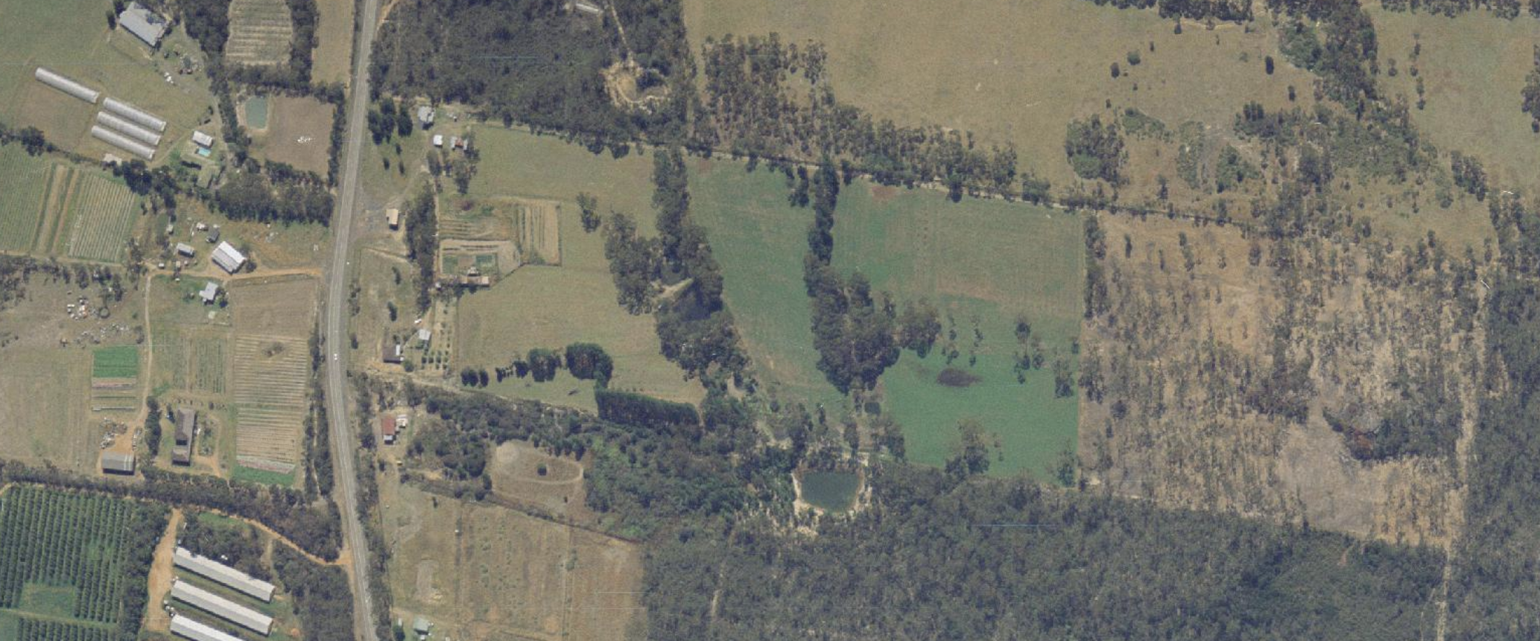
Figure 33. Aerial imagery of site 1994 (Source: NSW Government Historical Imagery)

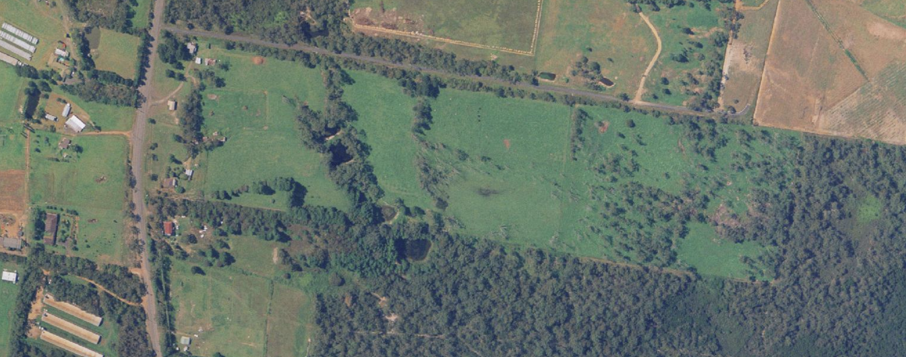
Figure 34. Aerial imagery of site 2002 (Source: NSW Government Historical Imagery)

Central Coast Local Environmental Plan 2022

The relevant local environmental plan applying to the site is the Central Coast Local Environmental Plan 2022 (‘the LEP’). The aims of the LEP include:
- to protect and promote the use and development of land for arts and cultural activity, including music and other performance arts,
  - to foster economic, environmental and social well-being so that the Central Coast continues to develop as a sustainable and prosperous place to live, work and visit,
  - to encourage a range of housing, employment, recreation and services to meet the needs of existing and future residents of the Central Coast,
  - to promote the efficient and equitable provision of public services, infrastructure and amenities,
  - to provide for a range of local and regional community facilities for recreation, culture, health and education purposes,
  - to conserve, protect and enhance the natural environment of the Central Coast, incorporating ecologically sustainable development,
  - to conserve, protect and enhance the environmental and cultural heritage of the Central Coast,
  - to minimise risk to the community in areas subject to environmental hazards, including flooding, climate change and bush fires,
  - to promote a high standard of urban design that responds appropriately to the existing or desired future character of areas,
  - to promote design principles in all development to improve the safety, accessibility, health and well-being of residents and visitors,
  - to concentrate intensive land uses and trip-generating activities in locations that are most accessible to transport and centres,
  - to encourage the development of sustainable tourism that is compatible with the surrounding environment.

The proposed development is not considered to be consistent with aims e, f and h in that the proposal would not protect or enhance the natural environment of the site or those located downstream of the site. The proposal is also not considered to be of a high standard of design given the extensive fill that is to be located on the site to accommodate the proposal.

Zoning and Permissibility (Part 2)

The site is located within the RU1 Primary Production Zone pursuant to Clause 2.2 of the LEP.

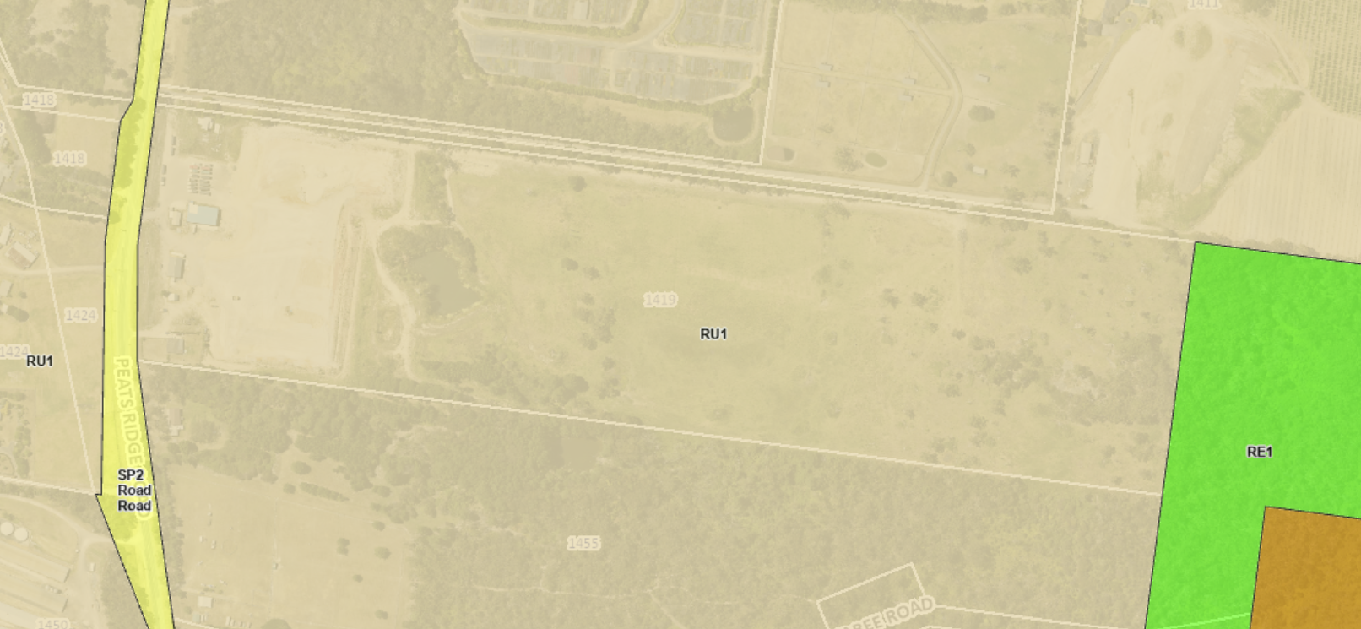
Figure 35. Zoning of the site under the CCELP 2022 (Source: Geocortex 2025)

According to the definitions in Clause 4 (contained in the Dictionary), the proposal satisfies the definition of Intensive Plant Agriculture which is defined as follows:

intensive plant agriculture means any of the following—
(a) the cultivation of irrigated crops for commercial purposes (other than irrigated pasture or fodder crops),
(b) horticulture,
(c) turf farming,
(d) viticulture.
Note—
Intensive plant agriculture is a type of agriculture—see the definition of that term in this Dictionary.

agriculture means any of the following—
(aaa) agritourism,
(a) aquaculture,
(b) extensive agriculture,
(c) intensive livestock agriculture,
(d) intensive plant agriculture.

The proposal is consistent with the above definition and intensive plant agriculture is a permissible use with consent in the Land Use Table in Clause 2.3.

The RU1 zone objectives include the following (pursuant to the Land Use Table in Clause 2.3):

• To encourage sustainable primary industry production by maintaining and enhancing the natural resource base.
• To encourage diversity in primary industry enterprises and systems appropriate for the area.
• To minimise the fragmentation and alienation of resource lands.
• To minimise conflict between land uses within this zone and land uses within adjoining zones.
• To protect high quality and productive agricultural land, water catchment areas and land comprising high ecological or biodiversity value from inappropriate development and land management practices.
• To provide for non-agricultural land uses that support the primary production purposes of the zone.

The proposed development is not considered to be compatible with the objectives of the RU1 zone as although intensive agriculture is a desirable use the works required to site the subject proposal are incongruous with the objectives of the zone.

General Controls and Development Standards (Part 2, 4, 5 and 6)

The LEP also contains controls relating to development standards, miscellaneous provisions and local provisions. The controls relevant to the proposal are considered in Table 4 below.

Table 4: Consideration of the LEP Controls
Control | Requirement | Proposal | Comply
Heritage  (Cl 5.10) | The effects on Aboriginal heritage are to be considered. | The site contains a number Aboriginal items. Further discussion relating to heritage can be found below. | Yes
Drinking water catchment (Cl 7.2) | Consent authority to determine any impacts to water catchment. | The impacts to the water catchment are not able to be determined based on the information provided. Further discussion of the clause can be found below. | No
Essential Services (cl 7.6) | Proposal is to demonstrate that services essential for the development are available. | The proposal has not demonstrated that required essential services are provided for the proposal. Further discussion of the clause can be found below. | No

The proposal is considered to be generally inconsistent with the LEP.

Clause 5.10 – Heritage Conservation

The site contains a number of Aboriginal objects. None of the identified Aboriginal objects are located within the area of the works proposed under the current application. Under Clause 5.10(2) consent is required for development involving the disturbance or excavation of archaeological site and where consent is required under clause 5.10(4), the consent authority prior to granting consent, must consider the effect of the proposed development on the heritage significance of the item concerned.

Several Aboriginal objects have been identified and registered with the Office of Environment and Heritage’s Aboriginal Heritage Information Management System (AHIMS) on the site. The site includes five registered culturally significant sites consisting of grindings and art.

An Aboriginal Heritage Due Diligence Assessment Report accompanied the application which has appropriately assessed the impacts to the items and provides appropriate controls for the development. The report recommended the following management strategies be implemented for the proposal:

- Recommendation 1
AHIMS 45-3-0096/45-3-1753, 45-3-1754, 45-3-1755 and 45-3-1756 should be avoided and conserved within their natural bush setting. The eastern portion of the Project Area should be considered an area of Aboriginal heritage sensitivity and treated as an exclusion zone, to prevent any impacts to the site complex. This exclusion zone should be clearly marked on all plans and construction drawings, and no impacts should occur within this area.

- Recommendation 2
Any Aboriginal on-site personnel should be informed of the highly sensitive cultural nature of the registered sites and to avoid the area.

- Recommendation 3
A cultural burn for the removal of overgrown vegetation around the sandstone rock/boulder
formation should be considered.

- Recommendation 4
An Aboriginal heritage induction should be delivered by representatives of the Aboriginal community to on-site personnel prior to commencement of works. All personnel are to be made aware of their obligations under the National Parks and Wildlife Act 1974; this includes protection of Aboriginal sites. The induction should cover procedures for identification and reporting of any new or suspected Aboriginal sites, including reference to the types of sites and sensitive landscape features in the local area (in particular, sandstone platforms/outcrops). This may be done through a toolbox talk or other suitable format.

- Recommendation 5
In the unlikely event that Aboriginal, or suspected Aboriginal archaeological material is uncovered during the development, then works in that area are to stop and the area is to be cordoned off. The Project Manager is to contact the Heritage Consultant to make an assessment as to whether the material is classed as Aboriginal object/s under the National Parks and Wildlife Act 1974 and advise on the required management and mitigation measures. Works are not to recommence in the cordoned off area until heritage clearance is given and/or the required management and mitigation measures have been implemented.

- Recommendation 6
In the very unlikely event that human remains, or suspected human remains are uncovered during the development, then works in that area are to stop and the area is to be cordoned off. The Project Manager is to contact the NSW Police to establish whether the area is a crime scene. If it is not a crime scene, and the remains are determined to be Aboriginal ancestral remains, then Heritage NSW is to be notified via the Environment Line on 131 555 and management measures are to be devised in consultation with the local Aboriginal community. Works are not to recommence in the area until the management measures have been implemented.

If consent were to be granted a condition of consent could require a Positive Covenant to be created at the rear of the site to protect the culturally significant items. The proposal could be made satisfactory in terms of clause 5.10 considerations but fails on other grounds.

Clause 7.2 – Drinking water catchments

The site is located within an area identified as the Mooney Dam Catchment as shown in Figure 36 and as such is captured by Clause 7.2. Development within the water catchment is to demonstrate that there would be no adverse impact on the quantity and quality of water entering the drinking water catchment. Measures are also to be implemented to avoid, minimise and mitigate the impacts of the development.

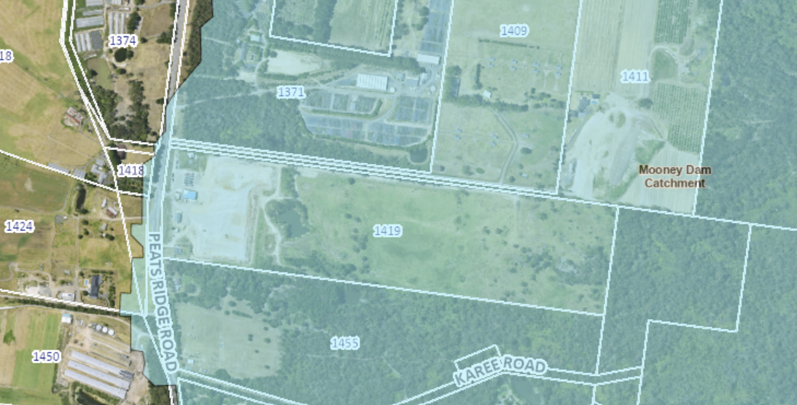
Figure 36. Drinking water catchment across the site (Source: Geocortex)

A watercourse traverses the site located through the site which would connect into the Mooney Dam Catchment. As discussed further within the report there is insufficient detail available within the submitted documentation for the application to demonstrate what the quantity and quality will be of the water which is leaving the site post development.

Water that currently flows through the site is proposed to be captured and stored within the raised dam on the site whilst water around the greenhouse will be directed downstream with no water quality measures in place. The amount of water to be utilised for the development is unable to determined at the present time given the end user is not yet identified. The proposed development has not provided sufficient information to demonstrate that the proposal can satisfy the requirements of Clause 7.2.

Clause 7.6 – Essential services

The above clause requires the proposal to demonstrate that the development that all essential services for the development are available or appropriate arrangements have been made. As discussed in detail further within the report the proposal has not demonstrated that sufficient services relating to the supply of water, disposal and management of sewerage, stormwater drainage or on-site conservation, suitable vehicle access and management of waste is available for the proposal.

The adequate provision of services is unable to be determined mostly as a result of insufficient information. The proposal therefore cannot satisfy the requirement of Clause 7.6.

- Section 4.15 (1)(a)(ii) - Provisions of any Proposed Instruments

There are no proposed instruments that are relevant to the proposal.

- Section 4.15(1)(a)(iii) - Provisions of any Development Control Plan

The following Development Control Plan is relevant to this application:

- Central Coast Development Control Plan 2022 (‘the DCP’)

CCDCP 2022, Chapter 2.6 – Commercial Hydroponics

The proposed development has been assessed against the above chapter. It is noted that the end user of the greenhouse has not been determined and as such the final details as to the growing methods to be undertaken with the greenhouse are unknown. An assessment against the chapter is shown in the following table which shows areas of non-compliance for the proposal.

Requirement | Proposal | Complies
2.6.1.3 Glossary
The chapter applies to commercial hydroponic development with an area greater then 2,000m² | The proposed greenhouse would have an area of approximately 35,145m². | Yes
2.6.1.5 Suitable Locations
To identify site constraints to minimise potential for land use conflicts. | The site has a slope across the land that the development seeks to address with an extensive amount of fill in order to provide a level platform for the proposed greenhouse. The rear of the site also contains items of Aboriginal heritage which limits the ability of the development to be across more of the site with potentially less of a need for such extensive filling. The proposal has not sufficiently addressed the site constraints to design a development that does not require so much filling. | No
2.6.2.1 Water quality and water supply
Surface and ground water resources are not to be adversely impacted upon by hydroponic activity. | The proposal will involve works within a watercourse and the water catchment. Based on the information available the full impacts on the watercourse and catchment are not able to be determined. | No
2.6.2.2 Noise and Odour
Commercial hydroponic activity is to have minimal adverse impact on the amenity of surrounding areas by way of noise and odour. | There is insufficient information available to determine the future noise and odour impacts of the proposal given there is no end user identified for the proposal. | Yes
2.6.2.3 Visual Impacts
Visual impacts of hydroponic development are to be minimised. | The proposal will require extensive fill on the site which could create visual impacts from the development. The proposal is also to include the removal of existing trees on the site which may have screened the development from the road and adjoining properties. | No
Dense landscaping or landscape mounding measures are to screen landscape structures. Plantings are to be advanced species. | No landscape plans have been provided and no landscaping is proposed to be provided on the site. | No
Greenhouse structures are to be setback a minimum of 30 metres from front boundary and 10 metres from side boundaries. | Minimum side boundary approximately 50m north and 70m to the south. These setbacks are to the proposed building and not the fill pad and retaining structures which are located within three metres of the southern boundary and around 20 metres to the northern boundary. | No
Future maintenance is to be considered in planting programs. | No details of have been provided of any future plantings on the site. | No
Materials and colours are to compliment the landscape in visually exposed locations. | No colours. Covered in film. | Yes
Vegetation should be retained and mass plantings established to enable effective screening of light coloured and reflective structures. | The proposal will require the removal of 134 trees from the site to accommodate the fill pad and drainage works. Additional vegetation may need to be removed to accommodate the access road. Insufficient details have been provided to determine the total amount of vegetation removal. | No

The proposed development is not consistent with the requirements of the above chapter in that site is not considered to be suitable for the site constraints and there are insufficient details available to assess the potential future impacts of the proposal.

Scenic Quality and Character Statements

The site is located within the plateau area and the site is captured by the Peats Ridge 3: Agricultural Plateau and Hillsides – Existing character precinct. The following is an extract from the desired character attributes required in this precinct:

“Ensure that new buildings would not visually-dominate any property within these scenically-prominent settings. Minimise scale and bulk by using strongly-articulated forms, such as stepped floor-levels that follow natural slopes, and irregular floorplans, such as linked pavilions that are capped by individual roofs and separated by landscaped courtyards. Roofs should be simple forms without elaborate articulation, with wide eaves plus gentle pitches. Use extensive windows and shady verandahs, as well as a variety of exterior finishes and cladding rather than expanses of plain masonry or metal sheeting. Ensure that outbuildings are compatible with scale and design quality of the principal structures upon any property by using similar roof pitches and eaves, plus appropriate exterior materials and finishes.”

- Character Assessment:

The proposal involves a very large volume of fill up to a depth of 15 metres edged by a 1:2 batter. The proposed greenhouse building is not proposed to be stepped down the slope of the site as required by the desired character provisions. Adequate justification has not been submitted to support the current design. The chosen design solution has maximised the proposed imported filling. No reasons have been submitted regarding justification and why more balanced earthworks using a cut/fill arrangement has not been chosen.

The following contributions plans are relevant pursuant to Section 7.18 of the EP&A Act and have been considered in the recommended conditions.

- Central Coast Council Section 7.12 Local Infrastructure Contributions Plan 2024

This Contributions Plan has been considered, and contributions would be levied based on the value of works provided with the application. Were consent to be granted the payment of contributions would be required by a condition of consent.

- Section 4.15(1)(a)(iiia) – Planning agreements under Section 7.4 of the EP&A Act

There are no Planning Agreements applicable to the proposal.

- Section 4.15(1)(a)(iv) - Provisions of Regulations

The Environmental Planning and Assessment Regulation 2021 applies to all development applications in relation to such items as application type, compulsory contributions, notification of development applications and a range of many other details regarding development application requirements. With regards to this application, there is no specific clause that warrants discussion.

  - Section 4.15(1)(b) - Likely Impacts of Development

The likely impacts of that development, including environmental impacts on both the natural and built environments, and social and economic impacts in the locality must be considered. In this regard, potential impacts related to the proposal have been considered in response to SEPPs, LEP and DCP controls outlined above and the Key Issues section below.

The consideration of impacts on the natural and built environments includes the following:

- Context and setting –

Many of the existing developments within the locality has followed the slope of the land without excessive cut and / or fill been undertaken. The proposed development is not in keeping with development that has been done in the locality given the extensive changes proposed to the existing landscape.

- Access and traffic –

Access to the site is via Peats Ridge Road which is a regional road. The existing access to the site is considered to be suitable to cater for the projected vehicles both during the construction and operation period.

During the construction / filling works to be undertaken on the site there would be around 25,000 truck movements to bring the required fill to the site with the same amount of movements from the site with empty trucks. This number may be increased should any loads to the site be rejected. The traffic management plan provided for the site has not addressed the impacts of these traffic movements both on and off the site.

Based on the volume of fill to be transported to the site and the number of truck movements that would be required during the construction stage, the proposal will result in an unacceptable impact on the local road network for both road and traffic safety and road pavement deterioration impacts and is not supported

The following issues are still considered to be outstanding relating to road, access, traffic and parking considerations:

- With no source of fill identified,
  - Vehicle haulage routes are unknown.
  - No confirmed vehicle impact assessment including vehicle movements during construction as the routes taken to the site are not known.
  - The impact of these truck movements on the road network during construction cannot be assessed.
  - The requirement for any road or intersection upgrade works based on these vehicle movements is not known.
- The impact of dust and noise from truck movements during construction on local residents and local businesses is not known.
- The access road along the northern boundary will need to be upgraded and/or constructed to satisfy the requirements of Table 7.4 a of NSW RFS Planning for Bushfire Protection 2019 and as included in the referral comments from NSW RFS for the full length of the road, from the vehicle access crossing at Peats Ridge Road to the rear of the proposed greenhouse.
- The sections provided across the site of the fill pad in the civil engineering drawings do not include the access road along any of the greenhouse boundaries.
- There is a requirement for suitable access for a Category 1 fire appliance to within 4 metres of the static water supply where no reticulated supply is available. This is not possible with this proposed development footprint.
- A “safety railing” is shown on the architectural plans (Drawing number A302) with no details of what this safety railing is for i.e. is it for pedestrians or vehicles and what it is designed to manage, there is no standard detail or section through this safety barrier.
- Driveway long section shown on the engineering drawings does not indicate the constructed driveway levels, it is showing the long section for the existing ground levels only. There appears to be several different design surfaces shown on the long section without explanation between chainages 460 and 526.
- Details on sections of driveway that are proposed across existing or proposed retaining walls, such as the existing stage 1 platform.
- Vehicle swept path has been provided for a “T1DUB” (B Double) for the front part of the site adjacent to the existing stage 1 works, however the swept path for the heavy rigid vehicle (HRV) has been provided for the rear of the site. As such, it is not known if the design can cater for a T1DUB”/ B double so that it can enter and exit the site in a forward direction.
- The impact of as Location of proposed access road relative to the existing and/or proposed retaining wall for the fill on the stage 1 site has not been discussed by the application and cannot be assessed.
- One of the cross sections through the dam includes a 3 m wide trafficable track around the top of the dam, however not all sections across the dam include this vehicle access track. It is not clear how vehicles could actually reach this access track proposed around the top of the dam embankment wall.
- If the currently approved vehicle access crossing (VAC) is to be used for this development, the applicant needs to indicate its suitability for use for the proposed development, given the volume of fill required for this development and the number of truck movements that will traverse this VAC.

Further to the above a construction staging plan would be required for the works, including details of the construction of the driveway and fill pad for these proposed works and how they impact the works currently under construction (works at the front of the site).

The driveway and long section plan includes swept path analysis for part of the site. The plan does not include the edges of the proposed driveway. The details on the plan are difficult to assess due to the scale and line type used. Clear swept path analysis would be required along the driveway, turning areas, potential vehicle conflict zones like loading areas, carparking and areas of high pedestrian activity.

At the completion of the works there would be no access available along the southern boundary and details have not been provided regarding the storage of vehicles on the site once operational.

The interrelationship between the current approval at the front of the site and the proposed development have not been discussed in the application. This includes, but is not limited to:

- consideration for the pedestrian and vehicle movements between the front and rear greenhouses
- carparking areas for each development
- The design and construction of the proposed driveway around the north of the existing approved development, considering a retaining wall is approved at the northern edge of the packing shed footprint where the new driveway is proposed and it is unclear how the new work will relate to the broader use of the site,
- Other site features required to run the business, such as site office, sheds, storage areas.

Its is considered that there are a number of outstanding issues relating to access and traffic that the current application has not addressed and remain outstanding. Without the above issues been addressed by the applicant the proposal is not able to be supported..

- Utilities –

The site is currently not serviced and as such site relies on on-site servicing. The facilities provided at the front of the site, consisting of three W/Cs are proposed to be utilised. The application advised that these facilities would be able to cater for the staff that would be onsite with both the front and rear greenhouse developments. The current application is for a significant increase in potential production area for an agricultural purpose, and so it is expected that there would be an increase in the number of staff and visitors using the site. The proposed approach by the applicant is not supported by Council, and allowance needs to be made for additional staff and visitors on the site.
The applicant has provided that there is an existing groundwater license approval for this site however no details of this approval have been included in this development application. Council has no understanding of the proposed or required water use for this development for both potable and recycled water or similar or potential wastewater generation as a result of this development. The land application area for the existing and proposed onsite waste water application area is not included on the drawings.
- Heritage

As previously discussed within the report, the site has a number of items of aboriginal heritage located on the site. The proposal has been accompanied by a suitable aboriginal cultural heritage assessment report and measures are to be implemented on the site to ensure the heritage items are protected both during works and ongoing. The proposed development would also be required to stop works should any items of aboriginal heritage be identified during works.

- Other land resources –

As previously discussed the site is located within the Mooney Mooney Water Catchment area. The proposal will include works within water course that is identified on the site. The current application has not provided sufficient information to assess whether the proposal would have any impacts on the current water quality and quantity that will leave the site and make its way to the catchment.

- Water/air/soils impacts -

Site contamination

As previously shown the site has been used for intensive plant agriculture and grazing undertaken on the site. The site does not appear to have been used for any contaminating uses in the more recent past.

The proposed operations of the site will involve the storage and use of different chemicals on the site including fuel, oil and fertiliser. The application includes the following table demonstrating the amounts of chemicals to be stored on the site and typical amounts.

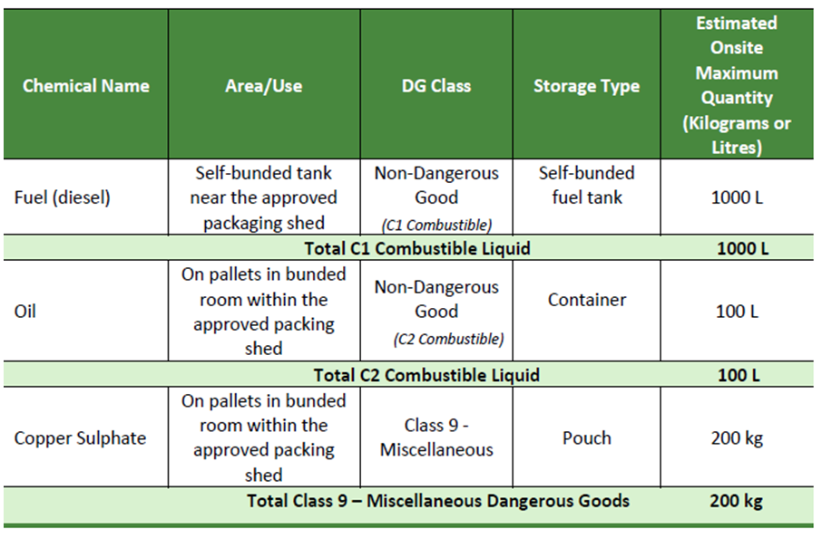
Figure 37. Typical Chemical storage on the site

A Preliminary Risk Screening and Environmental Assessment was undertaken for the site. A review of the information provided has found that the proposed volume of chemicals on site do not trigger the SEPP Resilience and Hazard threshold, therefore a Preliminary Hazard analysis is not required. All chemicals are proposed to be suitably stored and self-bunded.

It is noted that given there is no confirmed use of the approved and proposed greenhouses the identified dangerous and hazardous goods have the potential to change. The suitability of the storage of such substances is therefore not able to be satisfied given there could be additional substances stored on the site.

Earthworks

The proposal includes a significant amount of fill. The SEE states that 500,000 m³ of fill be required, and it may be sourced from tunnelling projects in Sydney or from the Central Coast. No further details are provided on the source of the fill. With no source of fill confirmed, the post developed geotechnical characteristics of the site cannot be confirmed by the applicant or assessed by Council.

Council previously requested details on the staging of the works or construction methodology with the sources of fill unknown. To date no details have been provided. The following issues remain outstanding related to the sourcing of the fill and construction methodology of the fill pad:

- Source of fill.
- Duration of filling activity.
- How geotechnical characteristics will be sustained during construction when multiple sources of fill will be used.
- Geotechnical characteristics and compaction of final landform.
- Construction methodology of embankment of fill platform without any benching or retaining walls proposed.
- Dust management during construction.
- Management of stormwater runoff during construction.
- Embankment slopes to be in accordance with requirements included in Councils Civil Engineering Specifications 2020 of 1 vertical to 4 horizontal and supported by geotechnical assessment.
- Concept design of rock revetment wall.
- Design of toe or footing of rock revetment wall.
- Construction of rock revetment wall given staging and duration of filling works.
- Interaction between the construction of this proposed development and the construction of the current approved greenhouse at the front of the site.
- The proposed expansion of the dam on the site appears to conflict with the location of the fill pad of the stage 1 development.

The engineering plans indicate a batter slope of 1V:2H along the southern and eastern sections of the fill pad, with depths of fill up to 14 metres in the south-eastern corner. Section 8.2 of the “Soils and Water Management Plan” states “It is anticipated that the fill batters will be progressively stabilised with rock armour or similar as the platform is built up. The temporary batters to the temporary sedimentation basin should be stabilised with vegetation or other appropriate measures”. There are too many unknowns with this engineering design. No details have been provided on how the filling will be undertaken across such a large footprint, how the embankment slopes will be managed during construction, and how the rock armour will be designed and installed across this filling process.

Section 8 of the “Soils and Water Management Plan” states that “Where practicable, the time from starting land disturbance activities to stabilisation should be less than six months. Stabilisation of the site means to start a program of vegetating, paving, armouring, etc. to be completed within a further 60 days.”. It is not clear what this 60 days is based on and whether this is the proposal for these works, given the works approved at the front of the site are still underway and have taken over 18 months to complete with less than 30% of the fill required than the works proposed in the current application, the 6 month or 60 day timeframe is not considered realistic.

Stormwater Management

An updated stormwater management plan was requested however has not been received to date. The most recent report prepared August 2024 has been assessed and the following issues have been identified.

The watercycle management plan does not acknowledge the role this existing basin plays in the treatment of stormwater and water runoff from the front approved development and the impact the rear proposed works will have on this.

The watercycle management plan (Acor Consultants, 31/05/2021) that was submitted as part of the approval of DA/54735/2018/A states that the harvesting and storage of water in the dam would meet irrigation demand for the front approved development 72.6% of the time, and the use of the dam water as an irrigation source achieves a potable demand reduction greater than 40%. It also stated that the dam is used for water quality purposes, to treat stormwater runoff from the front approved area.

The volume of the existing dam has been proposed to be augmented to cater for the stormwater runoff from the greenhouse roof, however no details have been provided on how this can occur while it continues to maintain a function for the front approved development for water quality and quantity management.

Section 5.4.1 of the watercycle management plan (Acor Consultants, 31/05/2021) that was submitted as part of the approval of DA/54735/2018/A states that the existing large dam also receives runoff from the upstream external catchment, which is predominantly bushland. The current application is proposing to raise the dam wall, however the watercycle management plan does not address the impact on the dams capacity to accept the flows from the upstream catchment with this raised dam wall. The civil engineering plans indicate a significant embankment in the location of the existing incoming channel from the north, without an alternate route or overland flow path for this water to follow shown as a result of the raised dam wall.

The civil engineering plans also show the augmented dam wall directly over the front approved development fill pad, retaining wall and the incoming pipeline from the front development area to the existing dam. The augmented dam wall is also shown to cover the existing “small basin” which is utilised by the front development. The requirement to re-route or reconstruct these incoming pipelines and associated infrastructure has not been discussed by the applicant and cannot be assessed by Council.

Section 6.4 of the Watercycle Management plan for this DA (Cubo Consultants, 30 October 2023) states “The existing greenhouse development includes a small sedimentation basin to the west of the main dam, collecting runoff from unsealed areas of the existing fill pad. Water from this basin exfiltrates to the main dam through a typical filter arrangement.” The loss of water quality treatment and storage capacity as a result of the covering sand removal of the existing “small basin” is not discussed. Section7.3.3 of the Watercycle Management plan for this DA (Cubo Consultants, 30 October 2023) states “In additional to the existing sediment basin controlling runoff from the existing unsealed roadways, a second sediment basin is proposed to control runoff from the proposed roadways.”. This implies that the existing sediment basin is included in the water quality and quantity calculations for this development.

The proposed augmentation of the dam wall appears to conflict with the front approved development as the footprint of the enlarged dam wall extends into the fill pad area and there has been no discussion on the integration between the existing and proposed works. Council considers that the proposed dam wall augmentation will cause an unacceptable obstruction to the flows from the front approved area and upstream area and is not supported.

The impact on downstream receiving environments, including the loss of flows in low and high rainfall events, and the impact it will have on downstream flora and fauna, has not been assessed by the applicant.

It is not clear if the development will necessitate the requirements for an approval for a “harvestable rights dam”. The current (November 2025) capacity for harvestable rights is 10% of the average annual regional rainfall runoff from a landholding. This proposal includes a significant routing of captured stormwater to the onsite dams for reuse on site only.

No details have been provided on the water quality treatment capability or design of the “permanent sediment basin” and the existing dam before it discharges off the site. As such, the water quality impacts cannot be quantified by the applicant and cannot be assessed by Council.

The proposed “rock lines revetment” embankment of the fill pad will facilitate overland flow for all water that falls on the top of the fill pad and embankment itself with no capture, conveyance or management of this flow at the base of the embankment. This will direct this runoff as sheet flow directly into the neighbouring property at No. 1455 Peats Ridge Road. This water will arrive much faster and at greater quantities and of an unknown quality, compared to the existing scenario. Council considers this an unacceptable impact.

No information has been provided on the water use within the proposed greenhouse, and the potential quality and quantity of runoff from this area. No details have been provided on the internal set up of the greenhouse, whether benches will be constructed or if produce will be grown on the ground in pots or in the ground itself. This has implications for water runoff from the produce that may contain chemicals and/or fertilizers that may infiltrate into the ground and groundwater or arrive at the dam. The applicant has stated that the final use of the greenhouse had not been determined. As such, the water quality impacts cannot be quantified by the applicant and cannot be assessed by Council.

The watercycle management plan states that the overflow from the dam will be directed into a shaped swale towards downstream watercourse. This swale appears to discharge at the southern boundary that differs from the existing location of the channel. The Engineering plans include a note that states “grassed swale min 0.5m deep min, 2m wide base, 1:4 batters, tail out to existing stream near boundary”. No details are provided on the design of the outlet at the boundary and how the existing vegetation in this area will be protected from the runoff quantity and quality. As such, the impact cannot be assessed by Council.
As demonstrated in the above discussion the proposal has not adequately addressed stormwater management for the proposal and Council is not able to support the proposal in terms of stormwater management based on the information available.

- Flora and fauna impacts

There are no Endangered Ecological Communities mapped on the site or directly downstream. According to the ecology report provided for the proposal two threatened species, the White-bellied Sea Eagle and Grey-headed Flying Fox have possibly been previously recorded on the Lot. There are no database records of threatened species from adjoining Lots.

The Arboricultural report provided for the development has identified 134 trees to be removed to accommodate the proposal. Of the trees to be removed 115 are native individuals and 25 exotic or dead individuals. Most trees to be removed are around the existing dam site or scattered paddock trees. There are no trees to be removed at the rear of the site within the Aboriginal exclusion area. Of the trees to be removed 22 are identified as hollow bearing trees.

To offset the impacts of the development on the environment the following mitigation measures would be required:

- Wildlife Management Strategy (WMS): To minimise habitat loss, particularly the removal of 22 hollow-bearing trees, and to enhance habitat value through salvaging hollows and installing 32 nest boxes. The provision of a WMS would focus on habitat creation to minimise the removal of the 22 hollow-bearing trees and within the eastern portion of the site.

- Vegetation Management Plan (VMP): Required for multiple sensitive areas, including riparian zones and culturally significant land, to manage weeds and improve ecological function. The VMP must be expanded beyond riparian corridors.

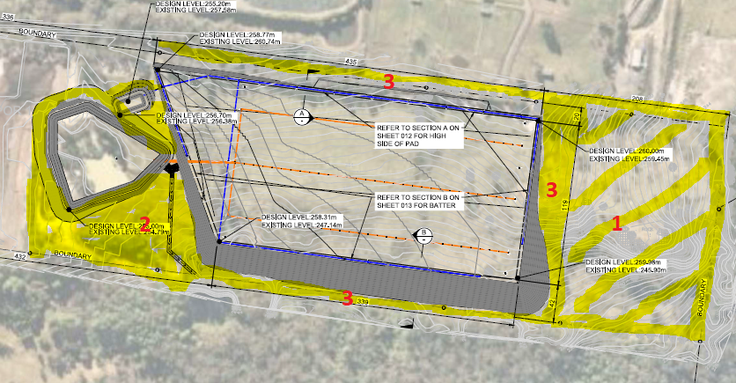
Figure 38. Site map showing (highlighted) areas to be managed by VMP and WMS.

- Permanent fencing to delineate the cultural zone/ VMP – WMS Area

- 88b/Positive Covenant over all vegetation and wildlife management areas and the exclusionary areas identified for ecological and indigenous cultural conservation, including the riparian areas nominated by DPE - Water.

The potential environmental impacts associated with the proposal have been considered and would require a number of mitigation measures to be applied. The proposed end impacts of the development are however not able to be determined as insufficient details have been provided regarding the access track along the northern boundary. As discussed further within the report under the bushfire section the proposal may require vegetation removal which has not been considered as part of the documentation provided.

- Natural environment –

The proposal would have a significant impact on the natural contours of the site given the substantial amount of fill that is to be imported and placed on the site. The site currently has a natural slope from the north down to the south however the proposal is to level out the site to create a level building platform.

The proposal has not demonstrated the need for such extensive fill with no alternatives, such as the benching of the site and the placement of smaller greenhouses on the site investigated. The proposed will also require works to be undertaken within the existing mapped watercourse with the raising of the existing dam wall. This could alter the flows of water within the water course and create impacts downstream of the site. Insufficient information is available to address the potential impacts from the proposal.

- Noise and vibration –

A Noise Impact Assessment (NIA) was provided for the proposal however this was found to be lacking information about surrounding receivers. The report was also found to be lacking information regarding the ongoing movement of Heavy Rigid Vehicles through the site upon completion along with not sufficiently addressing the vibration impacts of plant and machinery during the construction phase of the development.

An amended Noise Impact Assessment (Benbow, September 2025) was provided and has been reviewed. The amended NIA has accurately updated the sensitive receivers to residential and included a residential receiver (R13) that was not previously assessed. The NIA also updated scenarios to be more reflective of operation of site including HRV (waste truck) swept paths, car park use, updated construction scenarios and more detailed information of why vibration assessment is not required.

The predicted noise levels are meet during all operational scenarios. Minor exceedances are predicted during construction at one (1) receiver however this exceedance is not above the highly noise affected management level. The NIA includes mitigation measures for both operational and construction which would be conditioned. It is noted that the movement of trucks to and from the site during the construction period has not been addressed within the documentation provided.

- Natural hazards

The site is identified as Bushfire Prone land as shown in Figure 4 earlier within the report. The subject site includes a mixture of bushfire buffer and Category 3 vegetation. The application has been accompanied by a Bushfire Report and Addendum which outlines mitigation measures to be implemented on the site and requirements in regard to access. The application was also referred to NSW Rural Fire Service who had no objections to the proposal and provided conditions of consent.

Access to the rear of the site would be via an internal driveway located along the northern boundary. The access road would be required to be constructed of an all-weather trafficable surface to cater for emergency vehicles. Passing opportunities are required to be provided along the access road in accordance with the Planning for Bushfire requirements.
The access road along the northern boundary will need to be upgraded and/or constructed to satisfy the requirements of Table 7.4 a of NSW RFS Planning for Bushfire Protection 2019 and as included in the referral comments from NSW RFS for the full length of the road. The response to the RFI from Enviro Ecology states “To further protect retained trees adjacent to the access track, the applicant is willing to accept a condition of consent requiring the road to be either gravel-surfaced or constructed above grade, thereby ensuring no interference with root zones of trees upon the neighbouring allotment to the north within the road reserve”. As previously stated, the access track needs to be upgraded to satisfy the requirements of NSW RFS Planning for Bushfire Protection 2019, and with the fill proposed for this DA, it is not clear if the height clearance of 4 meters for fire fighting vehicle access is achieved.
The bushfire report however states that some vegetation clearing within the nominated formation could be required. The bushfire report and the arborist report have not provided details of any trees or vegetation that would be required to be cleared for the provision of the internal access road. The plans are also unclear as to whether the vegetation to be removed or impacted is located on the development site or the adjoining property. The final impacts of the access road are unable to be determined at the present time given the lack of final design and location of the northern internal road.

The referral letter from NSW RFS related to Planning for Bushfire Protection 2019 includes a requirement for the capacity of the road surfaces and bridges/causeways to enable a 23 tonne fully loaded fire fighting vehicle load. There are 3 x 750mm diameter pipes proposed under the access track at chainage approximately 335, however it is not clear if there is sufficient cover available and /or proposed to cater for the load of a 23 tonne fully loaded fire fighting vehicle.

An additional requirement of the proposal is for the provision of a 20,000 litre static water supply tank to be provided on the site. The tank would is required to be provided on the site and on a hardened ground surface for truck access. The plans do not indicate any fire fighting water supply on the site.

The proposal would also include an internal road around the perimeter of the greenhouse structure. This would provide a defendable space around the structure and also access to the area for emergency services.
The proposal is not considered to be suitable in terms of bushfire management of the site given the final details of the internal access road have not been provided.

- Economic impact

The development application is unclear on how many jobs the proposal will create. Some documentation states that no additional employees above what would be employed for the front development would be on the site whilst other documentation states that five additional greenhouse staff would be on the site at the completion of the current proposal. It is likely that the proposal would provide employment opportunities through both the construction and operational stages of the proposal it is unclear what the extent of employment would be. With no clear end user for the new greenhouse the staffing numbers are also unable to be determined.

- Site design and internal design

The proposed new greenhouse is to be located within a portion of the site that is subject to an existing slope. The design of the development, as previously discussed, has not addressed the constraints of the site in terms of the design proposed. The proposal could create impacts on and off the site as a result of the fill to be placed on the site and works within the water course.

- Construction

The proposal will require a substantial amount of truck movements along Peats Ridge Road to bring fill to the site as previously discussed. Peats Ridge Road may be of a suitable standard to cater for the temporary increase in traffic generation however given the lack of details regarding construction deliveries this is not able to be substantiated. It appears that suitable sight lines are available from the site to ensure safe access and egress to and from the site.

During the construction phase of the development various pieces of construction equipment will be required to be located on the site such as excavators, compactors and other equipment. Acoustic assessments of the impacts of the machinery have found there would be no significant acoustic impacts from the operation of machinery during the construction period however the impacts from the large amounts of trucks coming and going from the site to delivery soil has not been included as part of the assessment.

During construction it is proposed to level each load and compact it each day to ensure piles are not left on the site overnight to slump. As previously discussed the temporary measures to be undertaken to the fill platform during construction raise a number of outstanding issues.

- Cumulative impacts –

The proposal has the potential to create cumulative impacts both on and off the site. The proposal has the potential to impact on the approved front development through works proposed to the existing dam under the current application whilst the extent of other impacts are not able to be determined based on the information available for the application.

Additionally, the proposal is not consistent with the relevant planning controls or desired future character of the area. The approval of such significant fill on the site also sets an undesirable precedent for other developments within the locality.

Accordingly, it is considered that the proposal will result in any significant adverse impacts in the locality as outlined above.

  - Section 4.15(1)(c) - Suitability of the site

The site is not considered to be suitable for the type of development that is proposed. Although the site is prime agricultural land the constraints of the site make it unsuitable for the development proposed. The existing slope requires a significant amount of fill to create a level platform for the proposed greenhouse.

There has been no evidence provided with the application to suggest that other options may be more suited to the site, such as benching and smaller greenhouses stepped down the site, have been investigated. The existing constraints of the site would make it more suited to a less intensive agricultural use, such as grazing, which it is currently used for. The development that is proposed, being a large scale greenhouse development would be better suited to a site that is already levelled or would only require minor groundworks.

  - Section 4.15(1)(d) - Public Submissions

These submissions are considered in Section 5 of this report.

  - Section 4.15(1)(e) - Public interest

The proposal is not considered to be in the public interest as approval of such a development would result in a development that is not considered consistent with the desired character of the locality. The downstream impacts of the proposal are also unknown and not able to be determined based on the current information available.

- REFERRALS AND SUBMISSIONS

  - Agency Referrals and Concurrence

The development application has been referred to various agencies for comment/concurrence/referral as required by the EP&A Act and outlined below in Table 5.

There are no outstanding issues arising from these concurrence and referral requirements subject to the imposition of the recommended conditions of consent being imposed.

Table 5: Concurrence and Referrals to agencies
Agency | Concurrence/  referral trigger | Comments  (Issue, resolution, conditions) | Resolved
Concurrence Requirements (s4.13 of EP&A Act)
N/A
Referral/Consultation Agencies
RFS | S4.14 – EP&A Act  Development on bushfire prone land | The proposal involves works on bushfire prone land. RFS have provided recommended conditions of consent. The proposal has not sufficiently demonstrated that the proposal is able to meet the requirements with the provided bushfire report and the RFS due to insufficient information provided. | No
Transport for NSW | Section 2.121 – State Environmental Planning Policy (Transport and Infrastructure) 2021  Development that is deemed to be traffic generating development in Schedule 3. | TfNSW advised the proposal does not appear to meet the numerical criteria under Schedule 3. | Yes
Ausgrid | Section 2.48 – State Environmental Planning Policy (Transport and Infrastructure) 2021 | Ausgrid advised that a decision is not required for the referral. | Yes
Integrated Development (S 4.46 of the EP&A Act)
Natural Resources Access Regulator | S91 – Water Management Act 2000 activity approval under Part 3 of Chapter 3 | Application was referred to DP&E-Water who advised a stop the clock was required to address that although works had commenced at the front of the site a controlled activity approval had not be issued as required under the conditions of consent for DA54735/2018.  DP&E-Water were contacted and advised that issues relating to the development of the front of the site and any associated compliance action could be assessed independently of the referral for the rear of the site.  DP&E-Water have since issued General Terms of Approval (GTAs) that are to accompany any issued consent for the application. | Yes
Water NSW | S89 – Water Management Act 2000 Water Use approval | Water NSW advised that no dewatering or interception of groundwater exists so no assessment was required by Water NSW. Given the information available it is unclear whether the proposal would require an approval for a “harvestable rights dam” | No

  - Council Officer Referrals

The development application has been referred to various Council officers for technical review as outlined Table 6.

Table 6: Consideration of Council Referrals
Officer | Comments | Resolved
Engineering | There are a number of outstanding engineering issues associated with the proposal resulting in Council’s engineer unable to support the proposal based on the current information available. Relevant issues raised by the engineer are discussed within the report. | No
Water and Sewer | Standard requirements for water and sewer will be applied. | Yes
Traffic | It is noted however that details were not provided regarding the construction phase of the development as such did not form part of the Officer’s assessment as to the impact of the traffic movements during the construction phase. | No
Ecology | The application has sufficient information to address ecological issues raised. Necessary mitigation measures have been identified. | Yes
Tree | Recommendations of arborist report supported. | Yes
Environmental Health | The proposed environmental impacts of the proposal have been assessed in regard to issues such as acoustic, air quality, sediment and erosion control, contamination, etc. The officer found the information provided has sufficiently addressed the potential impacts and provided mitigation measures as required. | Yes
Environmental Health (OSSM) | Existing OSSM facilities approved on the site should be able to cater for any future staff on the site. | Yes
Waste | Sufficient waste management information provided. | Yes
Contributions | Contributions are applicable and are to be levied under Council’s Section 7.12 Plan. | Yes
Aboriginal Heritage | There should be no impact to Aboriginal Heritage on the site subject to the inclusion of proposed conditions of consent. | Yes (conditions)

The outstanding issues raised by Council officers are considered in the Key Issues section of this report.

  - Community Consultation

The proposal was notified in accordance with the DCP from 1 November 2024 until 29 November 2024. The notification included the following:

- Notification letters sent to adjoining and adjacent properties (34 letters sent);
- Notification on the Council’s website.

The Council received a total of two unique submissions, comprising two objections and no submissions in favour of the proposal. The issues raised in these submissions are considered in Table 7.

Table 7: Community Submissions
Issue | No of submissions | Council Comments
Impact on existing water supply for adjoining property. | 1 | The potential impacts to the quality and quantity of water leaving the site is not able to be determined based on the information available. The impacts to the existing water of the adjoining property are therefore currently not known.
General objection | 1 | No specific reason was provided for the objection.

- CONCLUSION

This development application has been considered in accordance with the requirements of the EP&A Act and the Regulations as outlined in this report. Following a thorough assessment of the relevant planning controls, issues raised in submissions and the key issues identified in this report, it is considered that the application cannot be supported.

The proposal is inconsistent with SEPP (Primary Production) 2021, CCLEP 2022 and CCDCP 2022. The likely impacts of the development are also not able to be suitably assessed with the information available, and the site is not considered to be suitable for the development proposed. The proposal is also not considered to be within the public interest.

It is considered that the key issues as outlined in Section 6 have not been resolved satisfactorily through amendments to the proposal and/or in the recommended draft conditions at Attachment A.

- RECOMMENDATION

That the Development Application DA/1424/2024 for Construction and Operation of Greenhouse be REFUSED pursuant to Section 4.16(1)(b) of the Environmental Planning and Assessment Act 1979 subject to the reasons for refusal attached to this report at Attachment A.

The following attachments are provided:

- Attachment A: Reasons for refusal
- Attachment B: Architectural Plans

